CLINICAL PRACTICE STANDARD –– Aeromedical & Special Operations
AO.CLI.22 – Mission Documentation

Document No. | D62499/26
File No. | E26/1206
Date issued | September 2026
Contents | Clinical Practice Standard | AO.CLI.22 – Mission Documentation
Contents | Appendices | N/A
Directorate | Aeromedical & Special Operations
Author Branch | Medical Retrieval
Branch Contact | Associate Director, Medical Retrieval  Phone: 0416 371 103
Summary | This procedure provides guidance on the expected mission documentation for Aeromedical Operations clinicians.
Applies to | NSW Ambulance aeromedical clinical crew.
Review Date | Sept 2027
Previous Reference | Nil
Status | Active
Approved by | A/Executive Director, Aeromedical & Special Operations, Dr Thomas Evens, 15 September 2026
Related Legislation | Nil
Related Documents | Nil

Compliance with this operating procedure is mandatory
CLINICAL PRACTICE STANDARD – Aeromedical & Special Operations
AO.CLI.22 – Mission Documentation

- Introduction
Mission documentation is an essential component of patient care. The Mission Case-sheet provides a written handover for the receiving facility and forms the medico-legal record which may be relied upon many years later. The vast majority of missions involve care of a single patient and thus the expectation of excellent documentation is very high.

- Purpose
To provide guidance on the expected mission documentation for NSW Aeromedical Operations clinicians.

- Procedure
  - All missions (Pre-hospital and Inter-hospital)
3.1.1 Creation of a Mission Case-Sheet
A unique Mission Case-Sheet and database entry should be created for every patient the service assesses or treats.

If the paramedic assesses the patient remote from the physician (such as a paramedic-only winch mission) they need to complete a Mission Case-Sheet and the physician can assist with completing the clinical database.

The only exception is a major incident/mass casualty Incident where multiple patients are assessed and/or triaged but not treated by our service.

3.1.2 Mission Case-Sheets
Prehospital Missions

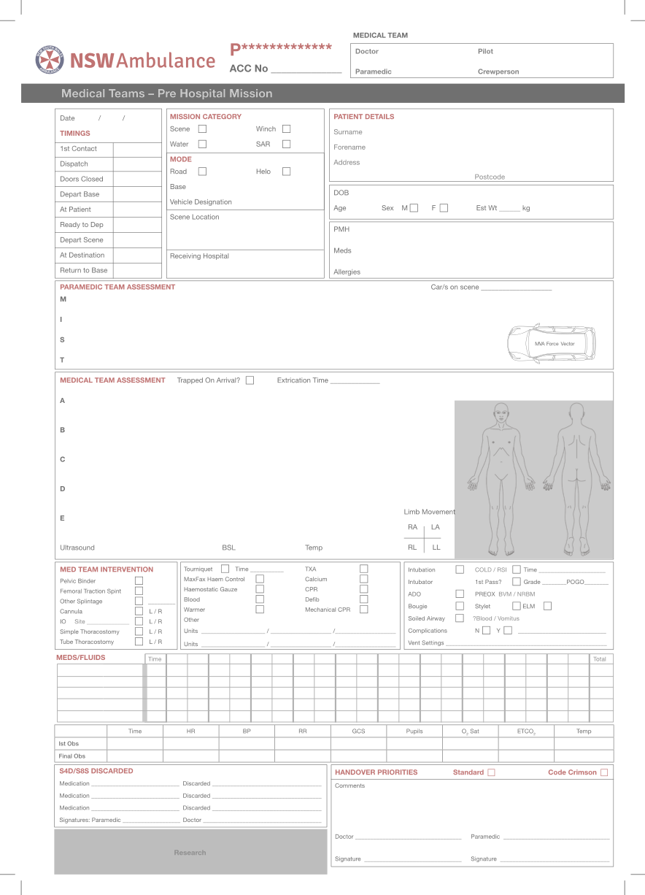

Interhospital Missions

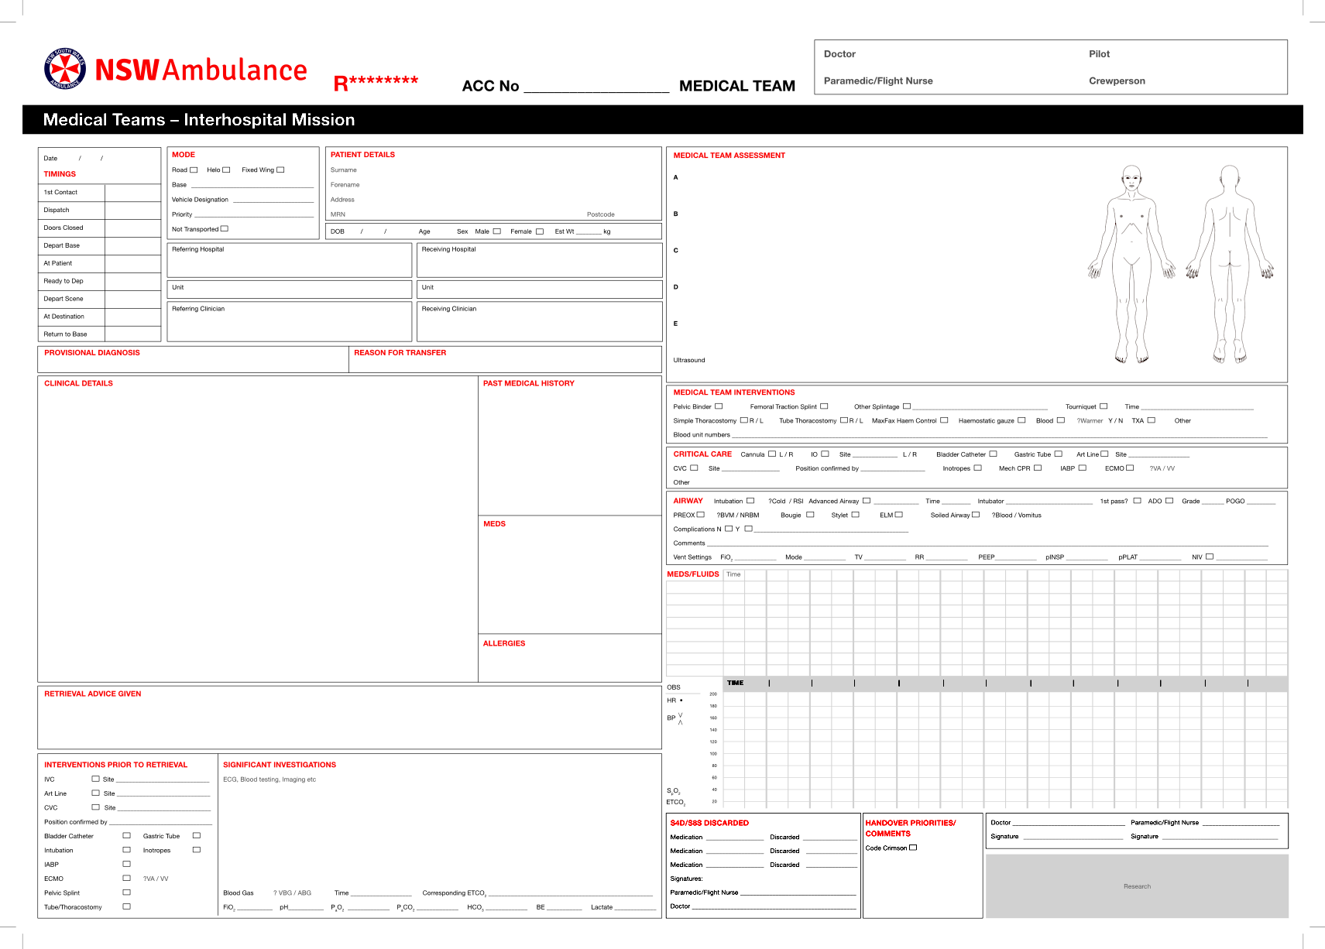
Scanning Nomenclature for StateWide Retrieval Database

Prehospital Mission Casesheet | P123456
Interhospital Mission Casesheet | R123456
Zoll X-SeriesTrend Summary | ZR/ZP123456
Coroners Form A | FAP/R123456
Blood Bank Paperwork | BBP/R123456
CMAC Video | CMACP/R123456
Anything Else | MISCP/R123456

All scans should be done on-base using NSWA scanners

3.1.3 Accurate Timings
Studies have shown that EMS timings are often inaccurate. Clocks and timepieces are unsynchronised and timings may have to be calculated retrospectively. All timings for the Mission Case-Sheet and database should be taken from a smartphone (or watch which has been synchronised to a smartphone). The ITIM app Retrieval Mission Timestamp function is recommended. All timings should be recorded prospectively. If there is doubt about a timing it can be often be verified by referring to aviation crew timings or Computer Aided Dispatch (CAD) system record.

3.1.4 Definitions
    - Time of First Notification: the first contact about the case – this may be the previous day in the case of booked backloads but will usually be the first call or batphone alarm time.
    - Dispatch: the time the team is tasked. This will usually be at the end of the phone call or bat phone alarm. In some cases it may be an agreed time for leaving base/home for a planned interhospital mission (eg. scheduled fixed wing departure).
    - Doors Closed: the time the clinical team is in the vehicle ready to leave.
    - Leave Base: the time the aircraft or road vehicle starts to move.
    - At Patient: the time the clinicians can physically touch the patient.
    - Depart Scene/ Hospital: the time the team begin to move from scene/bedspace with the patient with the intention of travelling to the receiving hospital.
    - At Destination: time the team arrives in the receiving hospital destination bedspace.
    - Return to Base: time the team arrives back at base.

3.1.5 Drugs/Fluids
All medications and fluids should be recorded. Both the incremental volume and concentration (or actual dose) must be accurately recorded. The time scale for TIME is usually 30min per large interval.

3.1.6 RSI
If an RSI is performed the following data points need to be recorded for the StateWide Retrieval Airway Registry:

    - Indications
    - Pre-oxygenation strategy
    - Time of induction
    - Induction doses
    - Patient positioning
    - Use of checklist
    - Operator/s
    - Number of looks
    - Grade of airway
    - Need for 30 sec drills
    - Complications

3.1.7 Ventilation
All patients who are being mechanically ventilated need to have their ventilator settings documented. These include:

    - Ventilator type
    - Mode
    - FiO2
    - Rate
    - I:E ratio
    - TV or PCV setting - preset tidal volume for volume controlled modes or preset inspiratory pressure for pressure controlled modes
    - PEEP
    - Peak or Plateau Pressure (In volume controlled modes at least one peak inspiratory pressure should be documented.) Where relevant (eg. ARDS) peak and plateau pressures should be recorded.

3.1.8 S4D/S8s
Clearly document if any S4D/S8s are obtained from either the hospital (e.g. infusions already underway) or from an on-scene crew (drawn up but not yet administered by the crew). At the conclusion of the mission any quantities of unused S4D/S8’s (including infusions connected to the patient) must be discarded and the discard signed for by both clinicians on the Mission Case-sheet.

3.1.9 Signing the Mission Case-Sheet
Every road and helicopter Mission Case-sheet should be double checked for completeness and signed by the doctor and paramedic to confirm the record is accurate and complete.

3.1.10 Amending Case Sheets
If a case sheet needs to be amended each new entry should be dated, signed and clearly labelled as “Addit:” to identify the timing of documentation.

  - Pre-hospital Missions

3.2.1 Summary/Assessment by Retrieval Team
The physician should record the initial assessment after arriving on scene and prior to any interventions – usually the primary and secondary survey in the form of ABCDE.
The diagram of the patient can be useful to annotate multiple injuries.

A – Patency and protection, indicators of difficult airway (e.g. cervical collar in-situ, bearded, limited mouth opening etc.)
B – RR, SaO2, O2 delivery or FiO2, chest palpation and auscultation findings
C – PR, BP, perfusion, visible haemorrhage, abdominal findings and visual assessment of pelvic integrity, long bone injuries
D – GCS and components, pupillary size and response and limb movements
E – Temperature, facial or extremity injuries, bruising, burns etc.
BSL if reduced GCS, log roll findings if performed.
3.2.2 Treatment by Retrieval Team
All physical interventions should be recorded: Splinting of pelvis or long bone, cervical immobilisation, dressings, surgical procedures, patient positioning etc. If you thought about a specific intervention and decided not to do it, it is useful to also document this. If performed please remember to document your ultrasound findings.

3.2.3 Recording Vital Signs
For the majority of prehospital missions the Zoll X-series is used to record patient vital signs. The Zoll X-series record should have the unique identifier (R or P-number) added to allow subsequent data retrieval. At the conclusion of the mission the data should be printed out (Vital signs/4 channel is the preferred format). The Zoll X-series data printout should be annotated where necessary (spurious readings or displaced probes etc). One copy is given to the receiving hospital and the second returned to base with the Mission Case for scanning into the clinical database.

In the rare event that the Zoll X-Series is not utilised (eg winch access to a patient) the vital signs should be recorded as for an interhospital mission.

  - Interhospital Missions

3.3.1 Significant Investigations
Any important investigations should be documented. A blood gas should be taken and EtCO2 correlated with PCO2 for all intubated patients.

3.3.2 Summary/Assessment by Retrieval Team
For interhospital missions the Assessment will be depend on the specifics of the patient and their pathology.

3.3.3 For intubated patients
- Tracheal tube size and cm at lips, cuff pressure.
- SaO₂, EtCO₂, chest auscultation, ventilator settings.
- PR, BP, heart sounds, perfusion.
- GCS and components, pupil size and response to light, any focal neurological finding.
- Temperature, BSL, existing tubes and lines. Further relevant examination.

3.3.4 Treatment by Retrieval Team
All physical interventions should be recorded: Patient positioning, all lines, tubes and surgical procedures. If you thought about a specific intervention and decided not to do it, it is useful to also document this. If performed please remember to document your ultrasound findings.

All discussions with the Duty Retrieval Consultant (DRC), State Retrieval Consultant (SRC) or receiving team should be documented.

3.3.5 Monitoring
Inter-hospital patients should have their vital signs recorded periodically. The frequency of documentation may vary according to team workload, mission duration, and acuity and stability of the patient. Relevant changes in physiology should be documented including responses to interventions. In stable patients 15 minutely observations should be considered a minimum standard for documentation. PR, BP (systolic, diastolic and MAP (where relevant)), SaO2, FiO2, EtCO2
Where relevant the temperature and pupillary size and response should be documented en-route and on arrival at destination.

- Electronic Medical Record Database - AirMaestro

3.4.1 For clinical governance and research
Record keeping on AirMaestro, the Aeroemedical Operations database, is the second part of the mission documentation.
An individual entry of a mission should be created with a specific identifier of case-sheet number (P123456 or R123456) by entering clinical information and uploading completed case-sheet with clinical files (Zoll monitor print-outs, CMAC videos, Form A and US recording etc). Correct documentation of the ACC number provides a ‘back-up’ mission identifier. This database is vitally important for clinical governance and research.

3.4.2 Diligence required
Like any other data collection, AirMaestro can only provide good information if data entry is performed diligently and careful consideration is applied to complete every single data point. “Think & Check” when completing Airmaestro entries will save time and effort in the long run.

3.4.3 In a timely fashion
While understanding that case entries onto AirMasetro could be delayed due to unpredictability of the clinical work, it should be made clear that such delay has ripple effects - decrease in accuracy regarding clinical information, effects on proper information gathering during 24-hr follow-ups and being left incomplete & forgotten.
All clinicians would be strongly encouraged to complete this data entry in a timely fashion, preferably within 48 hours of completing clinical missions.

- References
1. Ornato, J. et al Synchronization of Timepieces to the Atomic Clock in an Urban Emergency Medical Services System Annals of Emergency Medicine Volume 31, Issue 4, Pages 48 3–487, April 1998.

REVISION HISTORY

Version (Document #) | Amendment notes
Version 2.0 Sept 2027 | Minor amendments and inclusion of documentation on AirMaestro.  Approved by Executive Director, Aeromedical Operations
Version 1.1  WI2020-072  Issued May 2020 | Minor amendments and transition to new format.  Approved by Executive Director, Aeromedical Operations
Version 1.0  Issued October 2014 | Approved by Executive Director, Health Emergency & Aeromedical Services.

