CLINICAL PRACTICE STANDARD –– Aeromedical & Special Operations
AO.CLI.20 - Controlled Medications

Document No. | D62506/26
File No. | E26/1206
Date issued | September 2026
Contents | Clinical Practice Standard | AO.CLI.20 - Controlled Medications
Contents | Appendices | Nil
Associated Policy Directive/s and/or Operating Procedures/s | NSW Ambulance Medications Management Operating Procedure PRO2019-015
Directorate | Aeromedical & Special Operations
Author Branch | Medical Retrieval
Branch Contact | Associate Director, Medical Retrieval  Phone: 0416 371 103
Summary | This procedure provides guidance on the use and documentation of controlled medications.
Applies to | NSW Ambulance Aeromedical Operations doctors and paramedics.
Review Date | Sept 2027
Previous Reference | Nil
Status | Active
Approved by | A/Executive Director, Aeromedical & Special Operations, Dr Thomas Evens, 15 September 2026
Related Legislation | NSW Poisons and Therapeutic Goods Regulation 2008
Related Documents | NSW Ambulance Aeromedical Operations Paediatric Emergency Reference Cards  CSN81/12 - Electronic Notification to Report Lost, Missing or Suspected Stolen Restricted Medications  F3.3 Suspected Tampering of Restricted Medications – Management Toolkit

Compliance with this operating procedure is mandatory

CLINICAL PRACTICE STANDARD –– Aeromedical & Special Operations
AO.CLI.20 - Controlled Medications

- Introduction
Aeromedical retrieval teams commonly administer S4D/S8 medications to patients in the course of pre-hospital and inter-hospital critical care missions. NSW Ambulance Aeromedical Operations has an unusual place in the NSW Health system with regard to transporting patients on S4D/S8 medications between hospitals. It is essential that a clearly auditable documentation trail for S4D/S8 medications be maintained from receiving hospitals to referring hospitals. This procedure sets out the rules governing storage, checks, transfers between clinicians, documentation and the processes of dealing with breakages/loss/tampering of medications. They must be followed by all clinicians within NSW Ambulance Aeromedical Operations to comply with relevant legislative requirements and NSW Health policies including Clinical Safety Notices.

- Purpose
This procedure provides guidance on the use and documentation of controlled medications.

- Definitions
Restricted Medications on the NSW Ambulance Medication List refers to medications listed in the NSW Poisons and Therapeutic Goods Regulation 2008 as “Drugs of Addiction” (Schedule 8) and “Prescribed Restricted Substances” (Schedule S4D) S4D/S8s.

RESTRICTED MEDICATIONS (* stocked by Aeromedical Operations)

S8 “Drugs of Addiction” | S4D “Prescribed Restricted Substances”
Fentanyl*  Morphine*  Ketamine* | Midazolam*  Clonazepam  Lorazepam  Phenobarbitone

Thiopentone and Propofol are kept in a controlled safe and usage must be recorded as for S4D/S8s.

- Procedure
  - Medication Safety
4.1.1 Standard IV Concentrations:
All staff must be aware of the standard concentrations of S4D/S8 medications for IV administration by NSW Ambulance Aeromedical Operations.

Medication | Standard Concentration
Morphine | 1mg/mL
Midazolam | 1mg/mL
Ketamine | 10mg/mL
Fentanyl | 10mcg/mL

When preparing ANY other concentration of these medications (such as for paediatric patients) there is increased risk of medication error. “Paediatric” concentrations must be drawn up into alternative syringe volumes than standard concentrations and increased vigilance for dosing errors must be maintained.

Whenever possible mixing of sedation/analgesia infusions in the same syringe should be avoided (noting that on complex interhospital missions it may be necessary due to limited numbers of syringe drivers).

Whenever possible sedation/analgesia for intubated patients should be delivered by infusion using a syringe driver rather than boluses.

The NSW Ambulance Aeromedical Operations Paediatric Emergency Reference Cards must be used for all pre-hospital RSIs and contains age/weight-based dosing for all the commonly administered resuscitation medications and fluids.

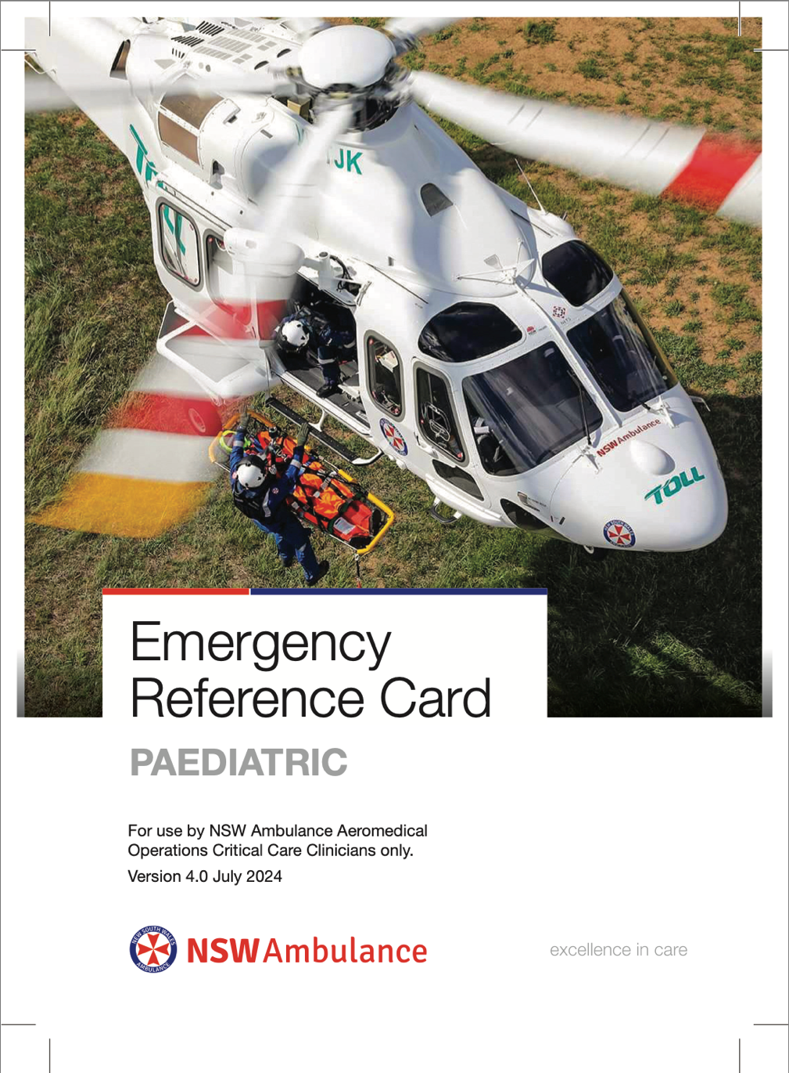

  - Medication Checks
All containers (bags, syringes) containing medications leaving the hands of the person preparing the medication must be clearly identified and labelled.

Any medication or fluid that cannot be identified, eg. in an unlabelled syringe, other container or preparation, should be considered unsafe and should be discarded.

Any fluid drawn up to be used as an IV flush, eg. 0.9% sodium chloride, MUST be clearly labelled.

4.2.1 Labelling Infusion Lines:
Administration lines dedicated for continuous infusions must be labelled to identify the active ingredient within the line.

4.2.2 Closed Loop Communication:
Closed loop communication must be used to direct administration of ALL medications given by the retrieval paramedic at the request of the retrieval physician. The dose and the total volume in millilitres (mLs) must be clearly stated. This must then be repeated back by the paramedic administering the drug and then confirmed prior to administration.

Numbers should be stated as both whole and constituent numerals: 16 should be said as “sixteen… one six”.

4.2.3 Medication Administration Cross-Check:
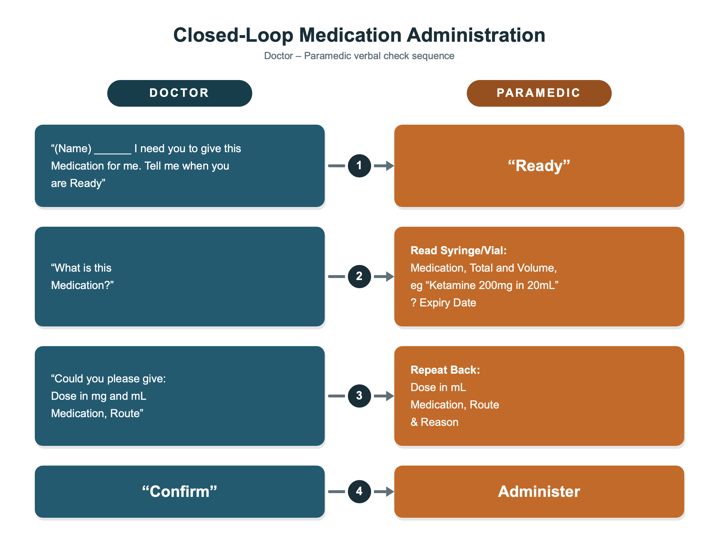
  - S4D/S8 Regulations
4.3.1 S4D/S8 Register:
A record of all transactions involving restricted medications must be made in the Restricted Medications Register. All entries within the register must comply with the requirements of the Poisons and Therapeutic Goods Regulation 2008.

A record including specific details must be made when restricted medications are:
- Received on base.
- Issued to a clinician at the commencement of a shift and return of stock at the end of the shift.
- Administered to a patient.
- Discarded in the case of residual medication when the whole quantity of the vial or ampoule was not administered to a patient.
- Disposed of when expired or damaged.
- Transferred from one helicopter base or hospital to another.

4.3.2 Receiving:
A clinician receiving delivery of an S4D/S8 medication must:
- Sign and date to document receipt of sealed package.
- Ensure that the package is securely stored in the Restricted Medications Safe immediately upon receipt.
- Record the receipt of the stock in the Restricted Medications Register with the signature of a witnessing clinician.

The entry for receipt of stock MUST be made using a red pen in the appropriate Restricted Medications Register and MUST record the following details:
- Date and time.
- Write “Stock Received” and the requisition number.
- Quantity of medication received.
- Total quantity of the medication in the Restricted Medication Safe following a physical stock count has been conducted in the presence of a second clinician. (This is the balance after the stock received is entered in.)
- Signature and employee number (or printed name) of authorised clinician who received the medication.
- Signature and employee number (or printed name) of clinician who witnessed the physical stock count.

4.3.3 Medication Storage:
A separate Restricted Medications register is to be kept for each restricted medication.

The name and strength of the medication must be recorded at the top of every page.

Entries into the register must be in black or blue pen unless red pen is specified.

Entries into the register must be legible.

Entries in the register must not be altered. Liquid paper or similar cannot be used. If an error is made, the authorised clinician must, in the presence of a second clinician, use a red pen and draw a single line through the incorrect entry next to which must be the clinician’s signature, employee number (or printed name) and date; then write the correct entry and sign, date and record employee number.

4.3.4 Start of Shift:
At the start of each shift, clinicians are issued with S4D/S8s from the Restricted Medications Safe to be kept in their flight suits for the duration of the shift. Paramedics are issued one yellow pouch and doctors are issued two pouches (one red vial pouch and one pre-drawn pouch) for the purposes of carrying these medications on their person.

The contents of each individual vial in each pouch must be signed for at the commencement of shift and the pouches must be kept on the clinician’s person at all times during the shift except when intending to administer medications and must be secured to the clinician immediately following administration.

At the commencement of shift, each clinician must, in the presence of a second clinician, sign for each vial of the contents in the GSA HEMS Restricted Medication Register and confirm all vials or syringes are:
- intact
- contents full and match stated volume
- within expiry date (please select the S4D/S8 medications with the shortest time to expiry at the beginning of your shift).

Whenever a clinician is on board a helicopter or road vehicle for a non-clinical mission (such as training, ferry flights or emergent equipment transport) they must have a full set of drug pouches in order to facilitate a re-tasking for a clinical mission.

4.3.5 End of Shift:
At the end of the shift, clinicians must attend the Restricted Medication Safe and, in the presence of a second clinician, sign back into the Restricted Medication Register and safe all vials or syringes confirming that they are:
- intact
- contents full match the stated volume
- within expiry date.

In circumstances where a single clinician needs to return S4D/S8 medications to the Restricted Medication Safe, they need to record the transfer in the Restricted Medication Register by signing in the first column with their employee number (or printed name) and then write “Single Officer” in the second column. This circumstance would be expected to be very rare. There is absolutely no reason this should occur during times when another clinician would be expected to be available to counter-sign.

  - Patient Handover
4.4.1 Inter-hospital Missions:
If a new S4D/S8 infusion (drawn up and appropriately labeled) is requested for patient care, whether connected to a patient or reserved for transport:
- A medication order needs to be written on a medication chart at the referring hospital by the retrieval physician. The original of this medication chart remains with the patient notes at the referring hospital.
- The Restricted Medication Register at the referring hospital must be signed for by the retrieval physician.
- Retrieval teams should not handover S4D/S8 medications to receiving hospital staff as this introduces significant risk of medication errors (non-standard concentrations) or medication diversion. Any S4D/S8 infusions running should be replaced by the receiving hospital using their own medications. After this, the retrieval physician must discard any remaining S4D/S8s medications, ie. remains of infusion not administered to the patient, in the presence of a second clinician and then sign for this on the mission casesheet.
- If an infusion of S4D/S8 medications has been drawn up in expectation of a prolonged transport requiring syringe changes, but the medication is not administered to the patient, it should be returned to base so that documentation can be completed. In the presence of a second clinician, the medication needs to be signed into the Restricted Medication Register, discarded and the discard signed for.
- Never take vials of S4D/S8s from a hospital.

4.4.2 Pre-hospital:
Only under exceptional circumstances, when the continuing treatment of the patient is vital, can a restricted medication be handed to Aeromedical Operations staff by an NSW Ambulance paramedic. The transfer must be documented on the mission casesheet.
If infusions are drawn/made up for ongoing clinical needs during transport, clear labellings of medication names, total amount and a total volume should be legible on the syringes. For example, Fentanyl 300mcg + Midazolam 15mg in 30ml. This information should also be documented on case-sheet, including the amount discarded at the receiving hospital.

  - Documentation of Administration of Medications
4.5.1 Administration:
Only NSW Ambulance Aeromedical Operations clinicians may administer Aeromedical Operations S4D/S8 medications. Medications are not to be administered by any other clinicians, paramedics, emergency service staff member, family or friends.

Prior to administration check the medication:
- drug name
- content in mg and mL
- expiry date
- integrity of the packaging incorporating the Removal, Integrity, Penetration and Effervescence (R.I.P.E. methodology).

4.5.2 Mission Documentation:
The NSW Ambulance Aeromedical Operations mission case-sheet is the official patient record and it is mandatory to complete one if there has been patient contact.

Administration of ALL medications (including non S4D/S8s) must be documented.

Entries must include medication name, time, dose/concentration and route.

4.5.3 Restricted Medication Register:
A clinician must record the details of all restricted medications administered to a patient in the Restricted Medications Register prior to the end of the on-duty shift. The entry must record:
- Date and time medication was administered.
- Name of patient to whom medication was administered.
- Case number (R- or P-number of casesheet).
- Quantity/dose of medication administered.
- Quantity/dose of medication discarded, in the case of only part of an ampoule or vial was administered to a patient (must be counter-signed by the second clinician who witnessed same) – see below.
- Quantity of medication in the store following a physical stock count (must be conducted in the presence of a second clinician).
- Signature and employee number (or printed name) of the clinician who administered the restricted medication.
- Signature and employee number (or printed name) of the clinician in whose presence the physical stock count was conducted.

4.5.4 Unused Residual Medication:
A clinician may destroy a restricted medication when the medication is:
- drawn up and not administered, or
- residual medication when the vial or ampoule was drawn up but not all was administered to a patient.

Medication discards must be recorded in the register as above and on the casesheet as follows:
- The clinician must make a record of both the dose administered to the patient and of the discard of the remaining portion of a restricted medication.
- A second clinician must witness the clinician discard the unused portion of the medication.
- Both clinicians must sign the case-sheet.

Needless to say, the amount of drug given to the patient plus the amount discarded MUST add up to the total amount of drug drawn up. Equally, the amount of drug given and discarded that is documented on the casesheet MUST correspond with the amount written in the register.

4.5.5 Restocking procedure:

In order to be mission-ready while returning to base, restocking of S4D/S8 medications, carried by clinicians, may occur at a different aeromedical base. Under these circumstances, the recorded administration/discards of S4D/S8 medications should be entered on Restricted Medication Registers AT THE BASE where the restocking procedure takes place.

  - Weekly Checks
The Station Officer, Duty Operations Officer, Medical Manager or delegate must conduct a weekly check of all medications including an audit/medication check of medication usage and recording.

The Zone Manager is responsible for providing a monthly report via the Deputy Director Operations to the Medications Management Committee.

Random audits may be conducted by managers within the service at any time.

4.6.1 Weekly Checks:
Checks must be recorded in the Restricted Medications Register as follows:
- Enter the date, time, quantity of stock in store and write ‘STOCK CHECK’.
- Entry must be in red.

4.6.2 Expired:
- Expired restricted medications must be removed from circulation immediately and quarantined apart from ‘in date’ medications to prevent administration of expired stock in error.
- Restricted medications MUST ONLY be destroyed by or under the direct personal supervision of a NSW Police Officer.
- The Station Officer or Duty Retrieval Consultant (DRC) is responsible for transporting expired drugs to be destroyed.

4.6.3 Medication Errors:
Report all medication errors through the Incident Information Management System (IMS+) and verbally to the Helicopter Duty Supervisor (HDS) for paramedics or DRC for physicians, immediately, or as soon as practical.

4.6.4 Lost or Missing:
If stock of a restricted medication is lost, missing or suspected to be stolen, the incident MUST be recorded and reported IMMEDIATELY.

The employee discovering the loss must:
- Make an entry in the appropriate Restricted Medications Register in red.
- Notify the HDS for paramedics and DRC for physicians.
- Submit an IIMS notification (as a Clinical Notification Type).

The HDS or DRC on receiving a notification must immediately:
- Notify the Medical Manager (for the DRC) or Zone Manager (for the HDS).
- Obtain a copy of the relevant entry in the Restricted Medications Register.
- Follow the process listed in CSN81/12 - Electronic Notification to Report Lost, Missing or Suspected Stolen Restricted Medications, and using the form http://intranet/asintranet/forms/SOPs/Patient+Safety+and+Clinical+Quality/3.2+Medications+Management.

The Zone Manager/Medical Manager must:
- Follow up the IMS+ report (as a Clinical Notification Type) relating to the incident.
- Prepare and provide a Briefing Note.
- Refer the incident to the NSW Police Force.

4.6.5 Suspected Tampering:
Suspected tampering of a restricted medication MUST be recorded and reported IMMEDIATELY as per F3.3 Suspected Tampering of Restricted Medications – Management Toolkit.

4.6.6 Breakages:
All breakages must be reported immediately and recorded in IIMS (as a Clinical
Notification Type) to the HDS for paramedics and DRC for physicians.

When a restricted medication is damaged it should be signed into the “Expired/Damaged” Register in red, signed by the clinician including employee number, (or printed name) and countersigned by a witness. The damaged medication can only be destroyed by the HDS or DRC in the presence of a police officer or registered pharmacist.

If a discrepancy with the Restricted Medications Register is found, it must be reconciled immediately.

If the discrepancy cannot be reconciled immediately the employee discovering the discrepancy must record and immediately report the incident to the HDS for paramedics and DRC for physicians, immediately, as for medications suspected stolen lost or missing.

The Zone Manager/HDS or Medical Manager/DRC will investigate the circumstances and report cases of suspected misconduct to the Deputy Director who will follow up with PSCU and the Chief Pharmacist, Pharmaceutical Services Unit, NSW Health (Phone: (02) 9391 9944).

APPENDICES
- N/A

REVISION HISTORY

Version (Document #) | Amendment notes
Version 4.0 June 2026 | Removed references to GSA-HEMS  Simplified standard concentrations for sedation/analgesia infusions  Minor amendments to restocking procedures
WI2020-116  Version 3.1  Issued 3 November 2020 | Updated in line with NSW Ambulance Medications Management Operating Procedure PRO2019-015
Version 3.0  WI2020-085  Issued 29 July 2020 | Minor updating – terms and added Propofol and Thiopentone.  Updated Pediatric Reference Card  Updated to new format and naming convention  Approved by A/Executive Director, Aeromedical Operations
Version 2.0  Issued 31 March 2017 | Minor amendments, and transition to new format.  Approved by Executive Director, Health Emergency & Aeromedical Services.
Version 1.0  Issued September 2012 | Approved by Executive Director, Health Emergency & Aeromedical Services.

