CLINICAL PRACTICE STANDARD – Aeromedical & Special Operations
AO.CLI.05 – Mechanical Cardiorespiratory Support
Document No. | D62486/26
File No. | E26/1206
Date issued | September 2026
Contents | Clinical Practice Standard | AO.CLI.05 – Mechanical Cardiorespiratory Support
Contents | Appendices | Appendix 1: Mechanical Cardiorespiratory Support – Vehicle Choice Matrix  Appendix 2: IABP Mission Checklist  Appendix 3-14: Restraint of devices in vehicles
Associated Policy Directive/s and/or Operating Procedures/s | AOC CLIN 2 – IABP Transfers  ACC.OPS.209 – Retrieval of Patients on ECMO
Directorate | Aeromedical & Special Operations
Author Branch | Medical Retrieval
Branch Contact | Associate Director, Medical Retrieval  Phone: 0416 371 103
Summary | This procedure provides guidance on the transfer of patients on mechanical cardiorespiratory support devices and the securement of these devices in NSWA vehicles
Applies to | NSW Ambulance Aeromedical clinicians
Review Date | December 2027
Previous Reference | AO.CLI.05 and AO.CLI.15
Status | Active
Approved by | A/Executive Director, Aeromedical & Special Operations, Dr Thomas Evens, 15 September 2026
Related Legislation | Nil
Related Documents | HELI.OSS.308 ECMO Transfers  HELI.OSS.390 Intra Aortic Balloon Pump (IABP) Transfers

Compliance with this operating procedure is mandatory
CLINICAL PRACTICE STANDARD – Aeromedical & Special Operations
HELI.CLI.05 – Mechanical Cardiorespiratory Support

- Introduction
NSW Ambulance Aeromedical & Special Operations is involved in the transfer of patients on mechanical cardiorespiratory support devices. These include Intra-aortic ballon pump (IABP) counterpulsation, extracorporeal membrane oxygenation (ECMO), Impella as well as combinations of these therapies. These transfers may involve road, helicopter or fixed wing vehicles. Transfers are inherently complex and often lengthy due to the requirement for specialised equipment and personnel and a high degree of planning, co-ordination and communication is required.

- Purpose
This procedure provides guidance on the safe transfer of patients on mechanical cardiorespiratory support devices and the securement of these devices in NSW Ambulance vehicles.

- Procedure

  - Intra-Aortic Balloon Pump (IABP) Counterpulsation

3.1.1 Background
IABP is inserted via the femoral artery in into the descending aorta. It is timed to inflate during diastole and deflate during systole with the aim of decreasing afterload and improving coronary blood flow. It is typically inserted for cardiogenic shock in the setting of myocardial ischaemia, acute valve rupture or for venting in V-A ECMO.

3.1.2. Referral and Tasking
The Aeromedical control centre (ACC) is the point of contact for the transport of adult patients on IABP therapy in NSW. In most cases the patient has already been commenced on IABP therapy at the time ACC is first contacted. The receiving hospital and the accepting Specialist(s) have usually been notified already and have accepted the transfer.

Tasking through ACC is in accordance with AOC CLIN 2 IAPB Transfers. Prior to tasking a conference call is held between the referring clinician, the State Retrieval Consultant (SRC) and the Duty Retrieval Consultant (DRC) at which point the appropriate platform and crew configuration are discussed. Following this the retrieval doctor(s) and paramedic / flight nurse can be conferenced for clinical handover. Clinical handover should include:
- Indication for IABP therapy
- Type of device (Arrow / Cardiosave) and balloon volume
- Assist ratio
- Degree of dependence on IAPB / assisted and unassisted pressures

A bariatric measurement chart should be completed and an accurate weight obtained for all larger patients (actual or potential weight given as >100kg). Bariatric IABP transfers require the appropriate stretchers for each vehicle type. Planning for bariatric IABP transfers should also refer to the appropriate work instructions for bariatric transfers.

3.1.3. Personnel
The following personnel may undertake IABP missions:
- Specialists OR registrars with >6 months experience with the service
- IABP VLE modules completed
- Up to date IABP currency
If IABP is combined with other forms of mechanical support, then the experience and currency requirements for this device should also be fulfilled.

Standard practice is to task two doctors: one trained to manage the pump exclusively, plus the usual doctor and paramedic / flight nurse retrieval team to manage the patient and logistics. On rare occasion where the patient is not ventilated and on minimal support a single doctor may be tasked after discussion with the DRC.

3.1.4. Equipment
All IABP transfers are conducted using the retrieval service Getinge Cardiosave Rescue device (wt 24.1 kg, dimensions 57.2 x 40.6 x 33.0 cm, battery life 90 minutes). There are two IABP devices currently used in NSW, Getinge Cardiosave and Arrow / Teleflex. Retrieval may require the transition between devices. Spare drive lines and adapters are carried on IABP missions for this purpose.
IABP missions are complex and may require additional syringe drivers and supplies of medications in anticipation of a prolonged mission duration.

3.1.5. Vehicle Choice and Securement
IABP missions may be undertaken by road, helicopter and fixed-wing platforms. See appendices for securing information:
- Road (Retrieval Ambulance): IABP secured in IABP lifter (Appendix 3).
- Road (MPV Lite): IABP secured in IABP lifter. Note the MPV lite lifter is positioned at 90 degrees to the retrieval ambulance lifter. The MPV lite has the benefit of seating for additional clinicians. It is the preferred option for combined Cardiohelp ECMO and IABP transfers (Appendix 4).
- Road (MPV): IABP secured to floor tracking in back right of vehicle using aircraft tie down straps without locator plate (Appendix 5).
- Helicopter: IABP secured to floor of AW139 using aircraft tie down straps and TAS IABP locator plate (Appendix 6). A helipad and paved walkway are required at both referring and receiving hospital. An ambulance with IABP lifter is required if any road leg is to be undertaken. Availability should be confirmed by ACC at the time of tasking.
- Fixed Wing: IABP secured to footplate of SPS stretcher in with B350 or PC-24. An ambulance with IABP lifter is required if any road leg is to be undertaken. Availability should be confirmed by ACC at the time of tasking.

3.1.4. Clinical Considerations
Clinical missions should be conducted in accordance with IABP checklist (Appendix 2). Further information is contained within the IABP VLE module and the videos accompanying the weekly IABP checks.

3.2. Extracorporeal Membrane Oxygenation (ECMO)

3.2.1. Background
Extracorporeal membrane oxygenation (ECMO) provides support in patients with severe organ dysfunction (respiratory and / or cardiac failure) refractory to conventional support strategies. Venovenous (V-V) ECMO involves drainage of venous blood and return of blood to the venous system after oxygenation. Venoarterial (V-A) ECMO involves drainage of blood from the venous system and return to the arterial system providing support in severe cardiac failure. Patients may be retrieved on V-V, V-A or hybrid combinations of ECMO. ECMO may be instigated by the referring centre prior to referral or be initiated by the ECMO retrieval team. Patients may also be transferred on ECMO combined with either Impella or IABP therapies.

3.2.2. Referral and Tasking
Referrals to ACC for ECMO transfers are managed in accordance with ACC work instruction ACC.OPS.209 – Retrieval of Patients on ECMO. On first contact the Clinical Coordinator will escalate to the SRC who will confirm indication and alert the ACCO / RLTC. A conference call will be held with the rostered ECMO service followed by a discussion with the DRC to discuss the appropriate platform and crew configuration. The ECMO device being used should be determined, noting that patients can only be transferred on a Cardiohelp device. If currently being supported on another device a new primed Cardiohelp circuit will need to be spliced in prior to transfer. If an ECMO transfer is agreed then a second conference call occurs between the SRC, DRC and retrieval team.
A bariatric measurement chart should be completed and an accurate weight obtained for all larger patients (actual or potential weight given as >100kg). Bariatric ECMO transfers require the appropriate stretchers for each vehicle type. Planning for bariatric ECMO transfers should also refer to the appropriate work instructions for bariatric transfers.

3.2.3. Personnel
The following personnel may undertake ECMO missions:
- Specialists OR registrars with >6 months experience with the service
- ECMO VLE modules completed
If ECMO is combined with other forms of mechanical support, then the experience and currency requirements for this device should also be fulfilled.

St Vincent’s Hospital (SVH) and Royal Prince Alfred Hospital (RPA) provide on call teams for adult ECMO transfers across the State, on a week about roster. The ECMO teams usually transfer patients back to their own ICUs. Rarely, a patient will be transferred to another ECMO capable tertiary ICU in Sydney.

The ECMO team consists of a perfusionist and a cannulator. The role of the ECMO team is to achieve cannulation, establish and manage the ECMO device. The medical retrieval team is required to manage the remaining usual aspects of the patient’s care as well as logistic and transport related oversight. Depending on the service an ECMO retrieval team may consist of 2 or 3 persons. This should be determined at the time of tasking.

Depending on patient factors, choice of vehicle and distances involved, an ECMO transfer might be expected to take between six and twelve hours to effect. Where possible a fresh team during daylight hours should be tasked. Where possible the ECMO and Retrieval teams should travel together to the referring hospital. The ECMO team can meet the retrieval team at Bankstown base or be picked up en route. At times it may be preferable to arrange for advance deployment of the ECMO team to referring hospital.

3.2.4. Equipment
All ECMO retrievals are conducted using the Getinge Cardiohelp (wt 10 kg, dimensions 31.5 x 22.5 x 42.7 cm, battery life 90 minutes).

The Getinge Rotaflow is not to be used for interhospital transfer. There is no approved means of securing all components of the device in any NSW Ambulance vehicle. Use of this device in the transport environment is contrary to the manufacturer’s advice.

ECMO missions are complex and may require additional syringe drivers and supplies of medications in anticipation of a prolonged mission duration. Typical oxygen requirements for the ECMO device are 2-5L/min via standard flow meter.

3.2.5. Vehicle Choice and Securement
Cardiohelp ECMO missions may be undertaken by road, helicopter and fixed-wing platforms. See appendices for securing information:
- Road (Retrieval, Cat A Ambulance or MPV Lite): Secured via Ferno bracket to CorPuls tracking on treatment pedestal (Appendix 8).
- Road (MPV): Secured to vehicle floor tracking via Ferno bracket and MPV Cardiohelp adapter plate (Appendix 9). This is the preferred option for combined ECMO / Impella transfers.
- Helicopter: Secured via ECMO footplate to SPS stretcher. Note this location is NOT suitable for road legs. Where packing and circuit length allow the Cardiohelp should be relocated to the treatment pedestal of the road vehicle and secured to the CorPuls tracking via the Ferno backet so as to remain accessible for monitoring and intervention in case of emergency. For helicopter transfers a concrete pad, paved walkway and height adjustable stretcher are required (Appendix 10).
- Fixed Wing: Cardiohelp secured to footplate of SPS stretcher in B350 or PC-24 (Appendix 11). Note this location is NOT suitable for road legs. Where packing and circuit length allow the Cardiohelp should be relocated to the treatment pedestal of the road vehicle and secured to the CorPuls tracking via the Ferno backet so as to remain accessible for monitoring and intervention in case of emergency.

3.2.6. Clinical Considerations
Management of the ECMO console is the responsibility of the team provided by the ECMO retrieval service. Although their primary consideration is the operation of the ECMO device, they are highly experienced clinicians. Clinical decisions should be made in close consultation while maintaining clear role delineation.

3.2.6.1. Cannulation and Initiation of ECMO
There is potential for significant blood loss and haemodynamic instability. Ensure the patient has large bore IV access, and blood crossmatched or in the room. Prepare to titrate inotropes / vasopressors and administer blood / fluid during cannulation and initiation. Once the ECMO run is established, inotropes and vasopressors may be weaned for a variety of reasons, including reduction in the acidosis causing myocardial depression and a decrease in intrathoracic pressures resulting in improved venous return.

3.2.6.2. General Management Principles
Prior to commencement of ECMO discuss anticipated difficulties, special requirements and haemodynamic goals with the ECMO team. Many of the sedation agents used are sequestered through the circuit. Long-acting agents like morphine and midazolam should be used for sedation with redundancy for transfer. Expect to run sedation at a higher rate than is usually required. Care should be exercised during patient handling to avoid kinking or disconnection of the circuit, air entrainment, or de-cannulation, which may cause serious patient harm or death. All 3-way taps in the circuit should have bungs and have stopcocks closed during transport. The lowest sweep on ECMO should start at 0.5 litres per minute across all modalities.

3.2.6.3. Management of V-V ECMO
The aim of V-V ECMO is to oxygenate and ventilate the patient. Oxygenation and ventilation are determined by cannula size, flow rate and sweep speed. Effective oxygenation occurs when > 60% of the patient’s cardiac output is captured by the ECMO circuit. In high cardiac output states e.g. sepsis, this may be difficult to achieve. Aim for an Sp02 > 85%. The primary aim of V-V ECMO is to allow for least damaging lung ventilation whilst still facilitating oxygenation and CO₂ removal. Atelectrauma can be avoided with the application of PEEP, reduced V_{T} (3-4ml/kg), PIP < 30 and an Fi0₂ < 0.5. It is not uncommon for patients to de-recruit and lose TV once established on ECMO, V_{T} should not be increased at the expense of raised transpulmonary pressures.

3.2.6.4. Management of V-A ECMO
The aim of V-A ECMO is to provide circulatory support to end-organs. The primary aim is not ventilation. If oxygenation is an issue, then a hybrid configuration of ECMO e.g. V-AV should be considered. Blood returning from the lungs to the heart is preferentially ejected by the native circulation to the cerebral and coronary circulations. If the lungs are not returning oxygenated blood to the heart this will result in cerebral and coronary ischaemia. It is therefore crucial that the ventilator is not turned off at any stage. Ventilator strategies are similar to those employed for V-V ECMO with more emphasis on reducing RV strain. SpO₂ measurements should be taken from right hand as this is the furthest point from the blood returning from the ECMO circuit and will be a surrogate marker of systemic perfusion. During V-A ECMO loss of pulsatile flow leads to loss of arterial pressure wave however MAP is reliable. Cardiac arrest should be treated along standard lines, noting however that in the case of V-A ECMO the patient’s circulation is supported by the pump even during cardiac arrest.

3.2.6.5. Troubleshooting
Access Insufficiency
CAUSE: Vein containing cannula is collapsing around cannula causing a ‘suck down’ effect. Occurs due to decreases in venous return (hypovolaemia; cardiac tamponade; coughing / straining; acute vasodilation (sedation bolus); increased abdominal pressure, excessive RPM / pump speed
SIGNS: Kicking of the line; unable to maintain circuit flows- unstable or dropping flows
TREATMENT: Drop the revs; give volume; remove the obstruction; consider a second cannula

Hypoxia on VV ECMO
CAUSE: Shunt – Blood enters the arterial system without going through the pump. Shunt will occur when CO >ECMO blood flow. If patient is hyperdynamic e.g. circulation running at 10L/min your ECMO circuit is only going to capture 5L/min. There is always going to be a shunt unless you match the patient’s cardiac output with the ECMO flow
TREATMENT: Increase the ECMO flow i.e. increase the proportion of venous return going to the oxygenator; Increase your oxygen carrying capacity by improving your Hb; Increasing the O₂ will not improve this (just like a physiological shunt)

Recirculation
CAUSE: Oxygenated blood from the return cannula is drained by the access cannula prior to entered the systemic circulation
SIGNS: Low arterial SaO₂ and high access cannula SaO₂ is an indication this is occurring; pulsating blood in the access line; flashes of bright red blood in the access line; access line and return line are the same colour.
TREATMENT: Access cannula needs to be 10-12cm away form drainage cannula otherwise you start to get recirculation

Further information is contained within the ECMO VLE module.

3.3. Impella
3.3.1. Background
Impella is an intravascular microaxial blood pump that provides temporary mechanical cardiovascular support. It is usually inserted for treatment of cardiogenic shock, venting for LV distension in V-A ECMO and during high-risk PCI. The device is inserted via the common femoral artery or the axillary / subclavian artery and connected to an external controller. The pump is positioned across the aortic valve providing antegrade flow from the LV into the ascending aorta. This results in improved systemic perfusion, increased coronary blood flow and a reduction in myocardial oxygen demand.

3.3.2. Referral and Tasking
ACC is the point of contact for transfer of patients on Impella. In most cases the patient has already been commenced on Impella at the time ACC is first contacted. Due to the requirement for additional staff from the ECMO retrieval centres, Impella retrievals are managed as per ECMO retrievals. On first contact the Clinical Coordinator will escalate to the SRC who will alert the ACCO / RLTC. A conference call will be held with the rostered ECMO service followed by a discussion with the DRC to discuss the appropriate platform and crew configuration. If transfer is agreed then a second conference call occurs between the SRC, DRC and retrieval team.
A bariatric measurement chart should be completed and an accurate weight obtained for all larger patients (actual or potential weight given as >100kg). Bariatric Impella transfers require the appropriate stretchers for each vehicle type. Planning for bariatric Impella transfers should also refer to the appropriate work instructions for bariatric transfers.

3.3.3. Personnel
The following personnel may undertake Impella missions:
- Specialists OR registrars with >6 months experience with the service
If Impella is combined with other forms of mechanical support, commonly V-A ECMO, then the experience and currency requirements for this device should also be fulfilled.

The Impella controller is operated by a member of the ECMO retrieval team. Unless combined with V-A ECMO usually only a single member of the team is required.

3.3.4. Equipment
Retrievals are conducted using the AbioMed Automated Impella Controller (wt 11.8 kg, dimensions 35.1 x 44.3 x 23.6 cm, battery life 60 minutes).
Impella missions are complex and may require additional syringe drivers and supplies of medications in anticipation of a prolonged mission duration.

3.3.5. Vehicle Choice and Securement
Impella missions may be undertaken by road and helicopter. See appendices for securing information. Impella transfers cannot be undertaken by fixed wing.
- Road (Retrieval or Cat A Ambulance): Secured via bracket to forward equipment shelf (Appendix 12).
- Road (MPV): Helicopter bracket secured to floor via MPV Impella adapter plate (Appendix 13). This is the preferred option for combined ECMO / Impella transfers.
- Helicopter: Secured to floor of aircraft floor tracking with floor plate and bracket (Appendix 14).
There is no approved mechanism for the transport of Impella in an MPV Lite or fixed-wing aircraft.

3.3.6. Clinical Considerations
Management of the Impella is primarily the responsibility of the team provided by the ECMO retrieval service.
On initial assessment check and document position of the Impella at the groin along with depth and securement. The Touhy-Borst adapter should be locked and tightened. Assess the groin for bleeding and check peripheral pulses. The angle of insertion should be maintained throughout transfer. Echo may be required to confirm position.
The pump is preload dependent, afterload sensitive and reliant on correct positioning. Target CVP > 10 where measured and MAP 60-80 mmHg. Avoid excessive patient movements avoiding traction during transfers. The head of bead should not be raised beyond 30 degrees.
Ensure the purge bag is attached to a drip stand or secured upright to vehicle bracket via carabiner.
In the event that CPR is required reduce Impella to level P2 and check position where possible. CPR and defibrillation should otherwise be delivered in accordance with existing protocols.

3.4. Combined Therapies
Occasionally patients may be transported on a combination of two mechanical cardiovascular support devices. Suitable vehicles and preferred options for each combination are listed in the Mechanical Cardiovascular Support – Vehicle Choice Matrix (Appendix 1). Note there is no mechanism to transport combinations of 2 mechanical cardiovascular support devices by fixed wing aircraft.

Road options are listed as preferred due to the ability to seat all clinicians in the rear of the vehicle as well as improved ergonomics for loading / unloading. The preferred option should be used unless the vehicle is unavailable and delay to await vehicle availability is clinically unacceptable after discussion with the retrieval team, referring and receiving centres.

The loading / unloading of multiple devices is complex and requires additional personnel. Ensure two persons per device are available and brief all movements prior to proceeding.

APPENDICES

Appendix 1 – Mechanical Cardiorespiratory Support – Vehicle Choice Matrix
Appendix 2 – IABP Mission Checklist
Appendix 3 – Restraint of IABP in Retrieval Ambulance
Appendix 4 – Restraint of IABP in MPV Lite
Appendix 5 – Restraint of IABP in MPV
Appendix 6 – Restraint of IABP in Helicopter (AW-139)
Appendix 7 – Restraint of IABP in Fixed Wing (B350 / PC-24)
Appendix 8 – Restraint of ECMO (Cardiohelp) in Retrieval Ambulance / Cat A Vehicle / MPV Lite
Appendix 9 – Restraint of ECMO (Cardiohelp) in MPV
Appendix 10 – Restraint of ECMO (Cardiohelp) in Helicopter (AW-139)
Appendix 11 – Restraint of ECMO (Cardiohelp) in Fixed Wing (B350 / PC-24)
Appendix 12 – Restraint of Impella in Retrieval Ambulance / Cat A Vehicle
Appendix 13 – Restraint of Impella in MPV
Appendix 14 – Restraint of Impella in Helicopter (AW-139)

REVISION HISTORY

Version (Document #) | Amendment notes
Version 4.0  Issued Sept 2026 | Change in name from ECMO Retrieval  Incorporation HELI.CLI.15 Intra-Aortic Balloon Pump (IABP) Transfers  Updated guidance for securing devices  Removal of ECMO Rotaflow transfers  Addition of vehicle choice matrix  Addition of IABP mission checklist  Approved by Executive Director, Aeromedical Operations
Version 3.0  WI2020-079  Issued 29 July 2020 | Comprehensive update including:  Rotaflow / Cardiohelp procedures  Vehicle specifics  Troubleshooting guide  Transition to new template and naming convention  Approved by A/Executive Director, Aeromedical Operations
Version 2.0  Issued 2014 | Updated to new version  Approved by Executive Director, Health Emergency & Aeromedical Services
Version 1.0  Issued April 2013 | Approved by Executive Director, Health Emergency & Aeromedical Services.

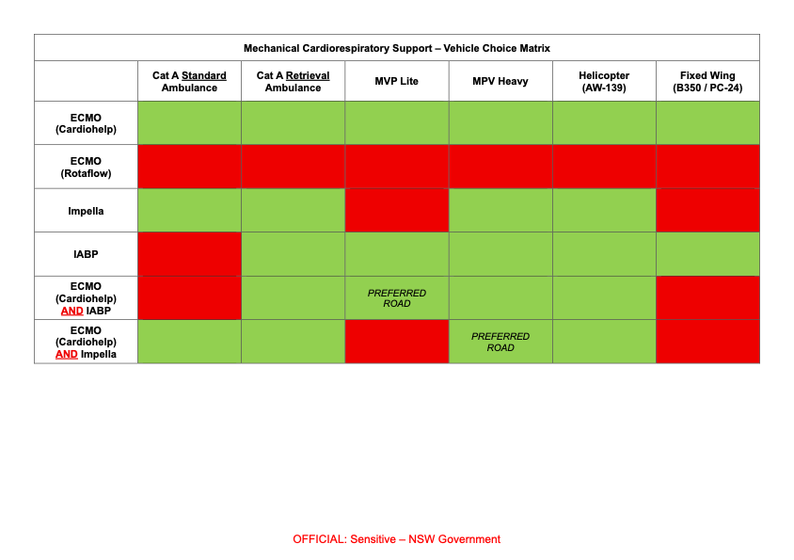
Appendix 1: Mechanical Cardiorespiratory Support – Vehicle Choice Matrix

Appendix 2: IABP Mission Checklist
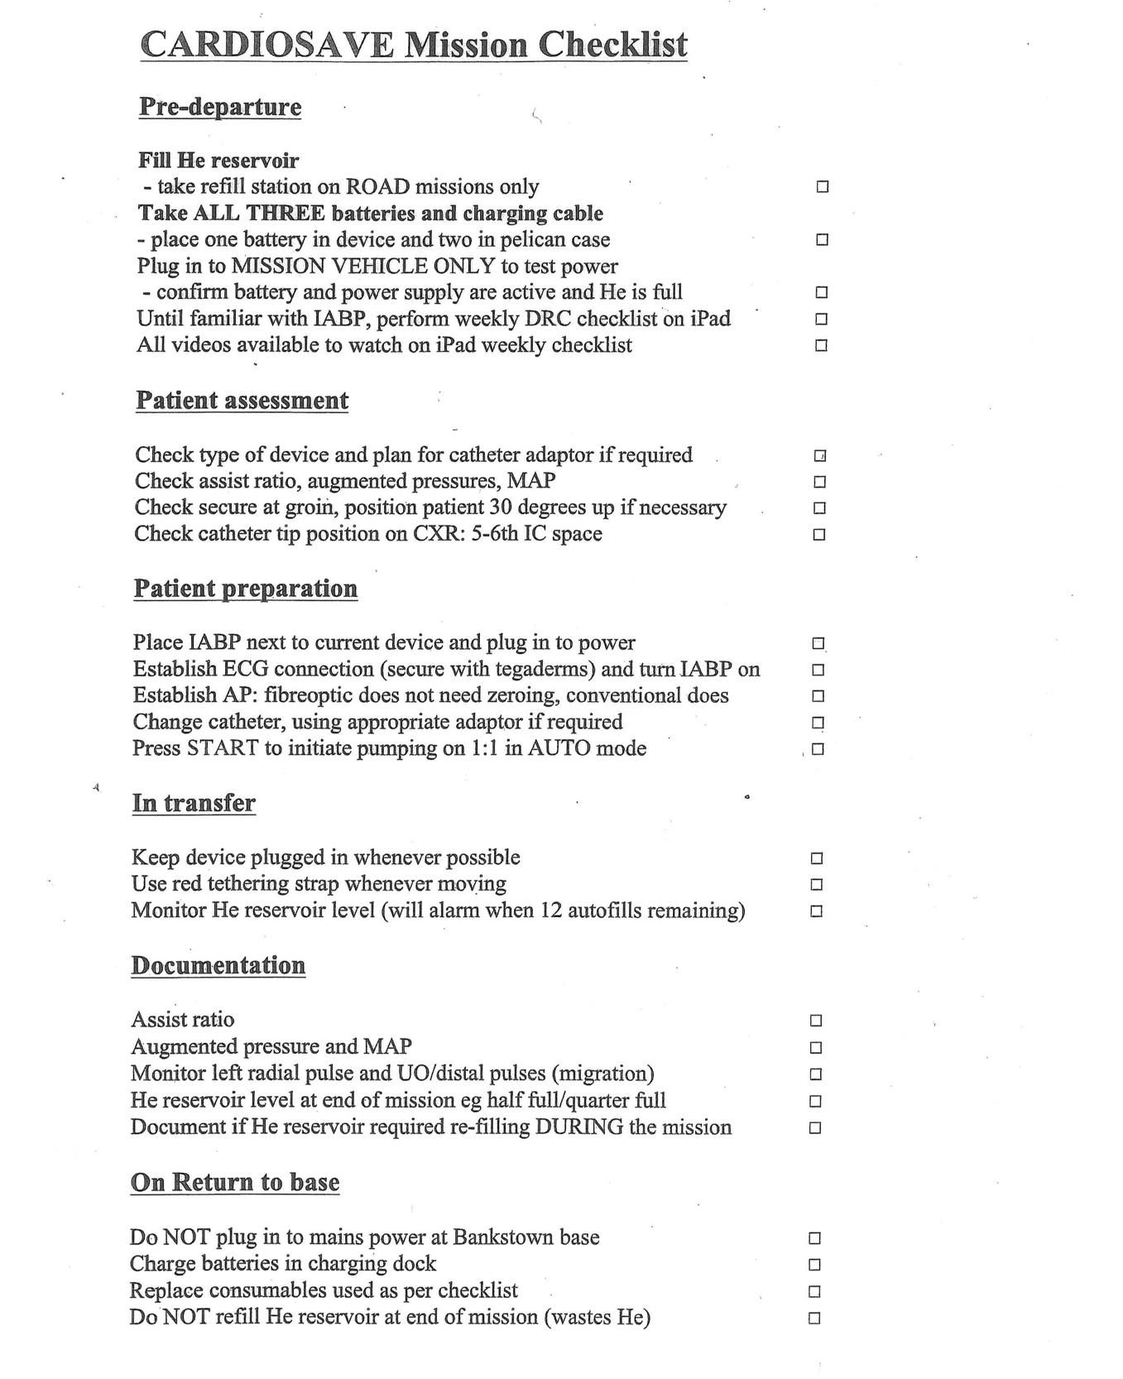

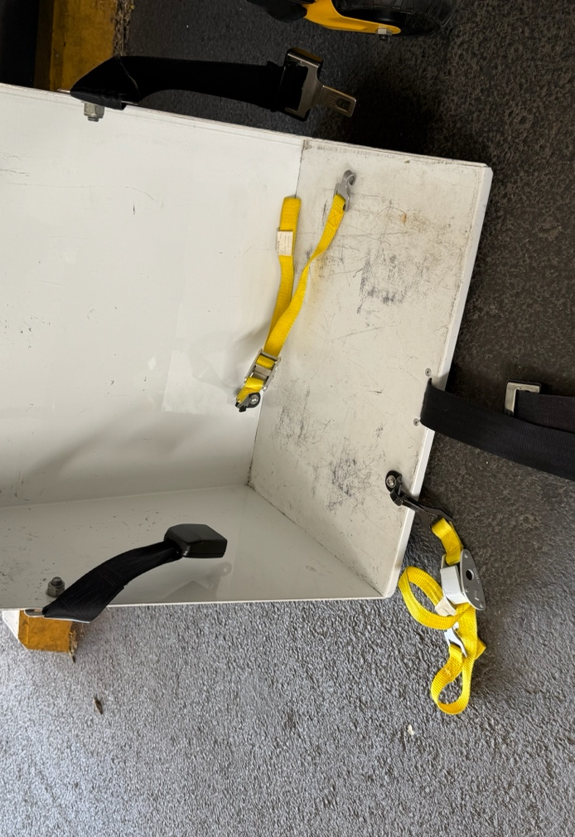
Appendix 3 – Restraint of IABP in Retrieval Ambulance

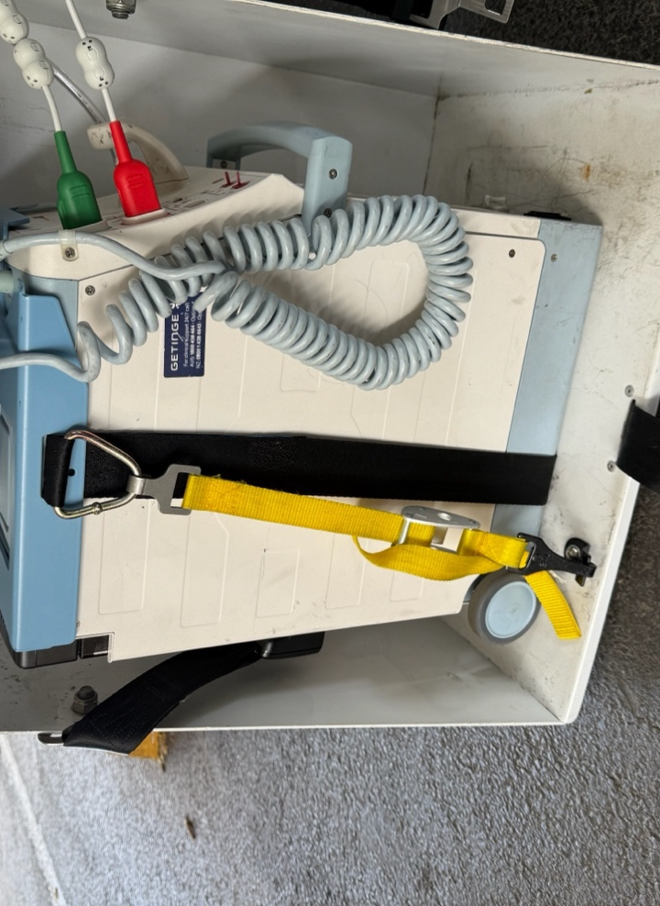
Figure 1: When packaging ensure cables and driveline are to patient’s RIGHT. Lower

IAPB lifter and attach yellow securing straps to lifter hard points. Bring the pump

and stretcher to the rear of the ambulance and remove red tethering strap

Figure 2: Lift IABP into lifter and secure both yellow straps to D rings of pump bracket

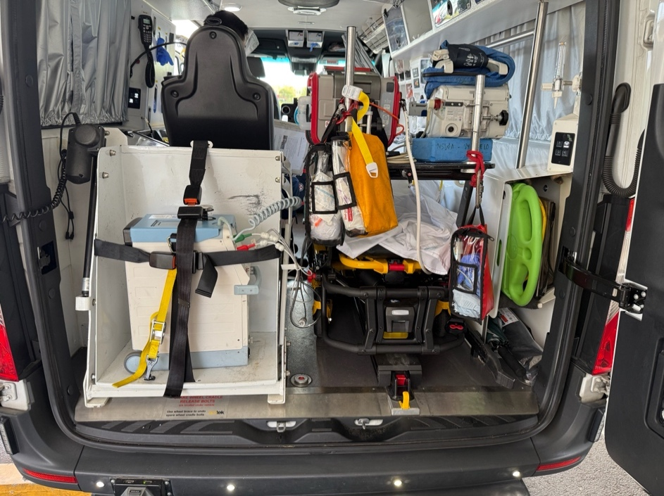
Seatbelts may be tightened in addition

Figure 3: Load stretcher and pump simultaneously maintaining vigilance

of cables and connections

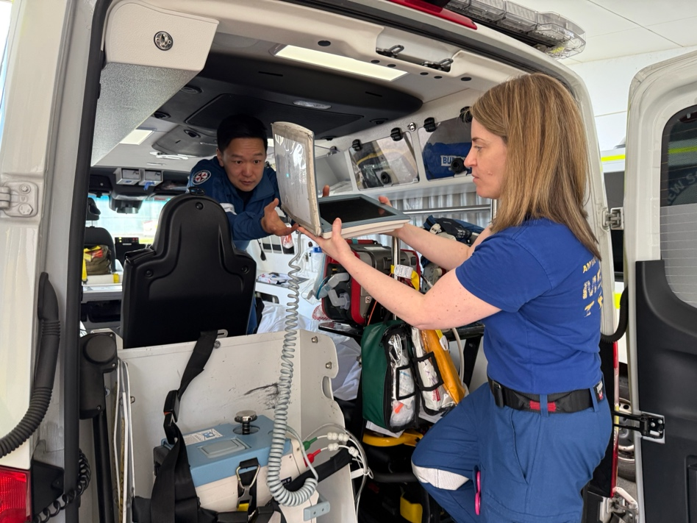

Figure 4: Remove screen and pass to clinician in treatment seat

The pump should be plugged into inverter power

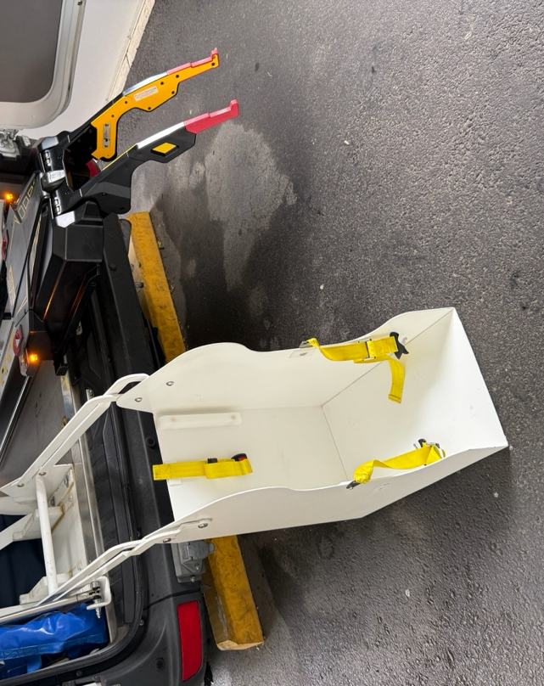
Appendix 4 – Restraint of IABP in MPV Lite

Figure 1: When packaging ensure cables and driveline are to

patient’s RIGHT. Lower IAPB lifter noting it sits at 90 degrees

to the retrieval vehicle. Bring the pump and stretcher to the

rear of the ambulance and remove red tethering strap
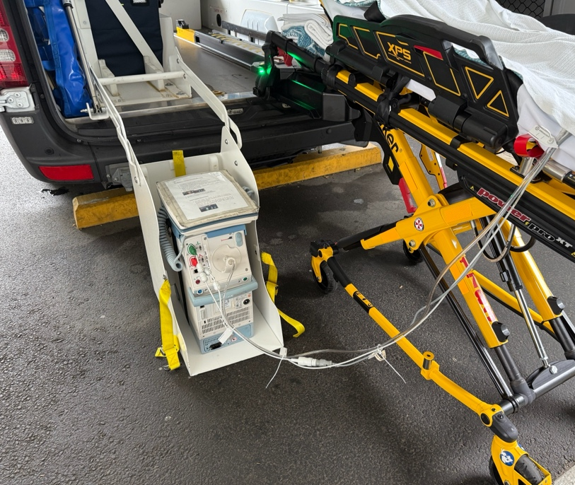

Figure 2: Place the pump in lifter with connections facing aft.

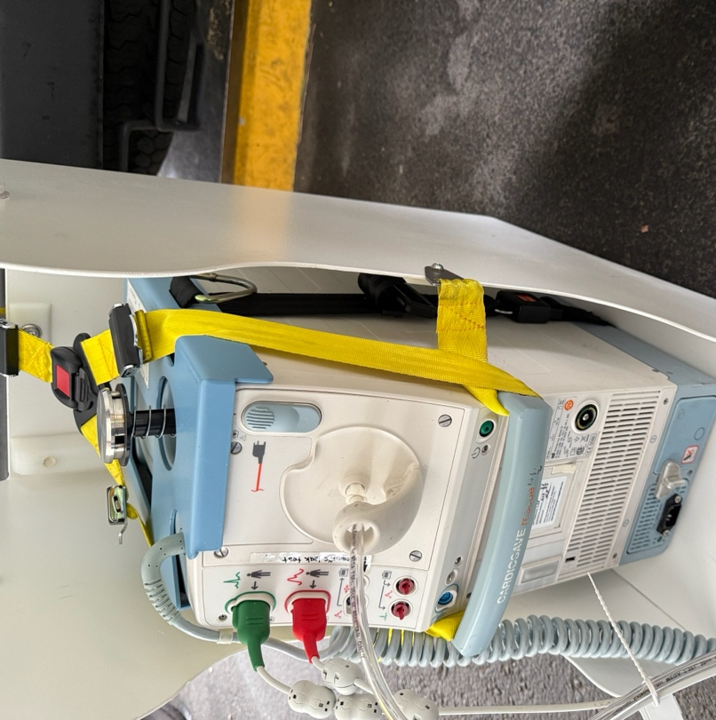

Figure 3: Loop the yellow straps through the handles of the IABP

as shown
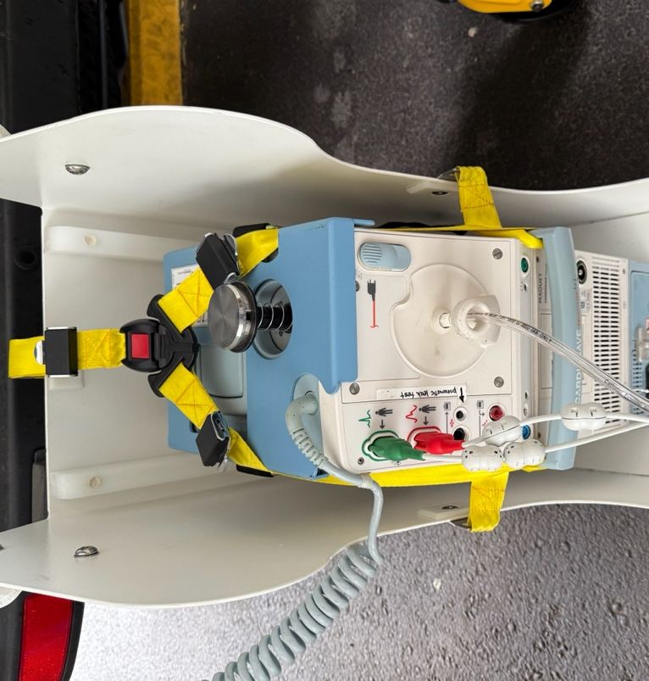

Figure 4: Shorten straps to ensure connecter is on top

of the device so it doesn’t interfere with the lines and connections

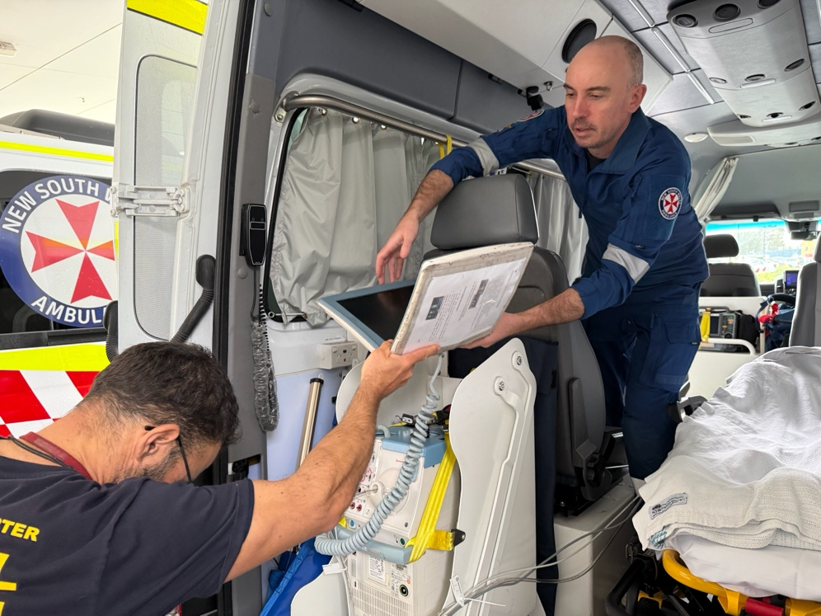

Figure 5: Load stretcher and pump simultaneously maintaining vigilance over

cables and connections. Ensure device is plugged in to power. Hand the

screen to treating clinician
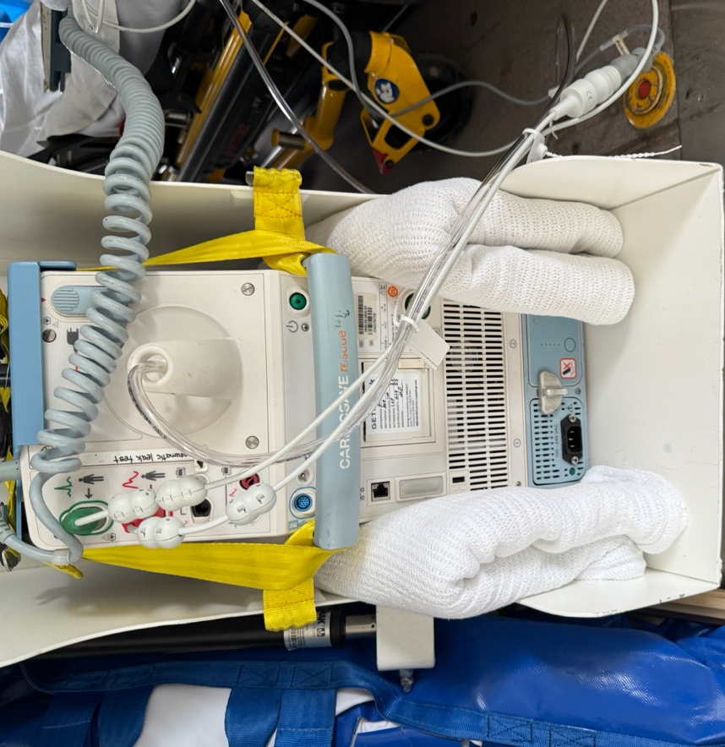

Figure 6: Blankets may be used to ensure a snug fit ensuring that fan

vents are not blocked

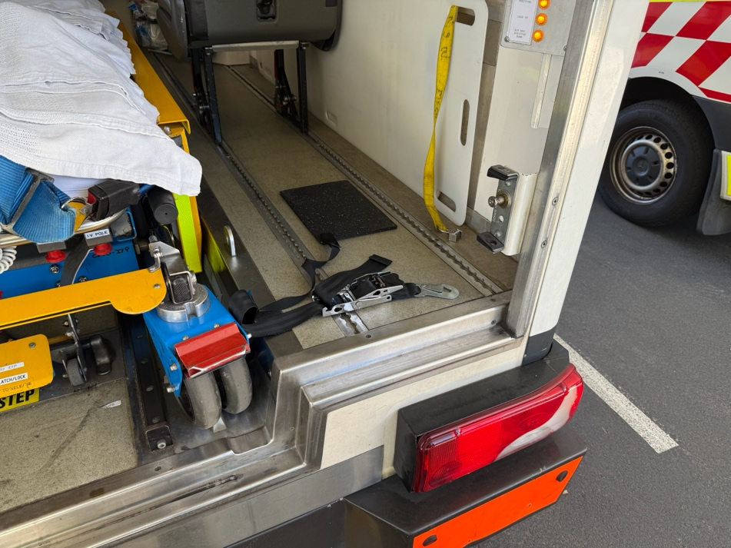
Appendix 5 – Restraint of IABP in MPV

Figure 1: When packaging ensure cables and driveline are to patient’s

LEFT. Bring the pump and stretcher to the rear of the ambulance and

remove red tethering strap. Adjust rear right seat and place mat on floor
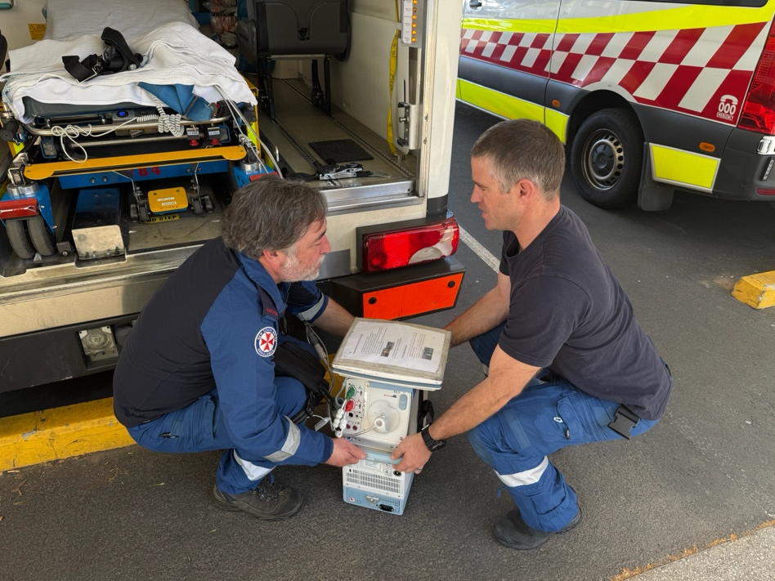

Figure 2: Load stretcher and pump simultaneously maintaining vigilance

over cables and connections. The pump is lifted (2-person lift) on to rear

right floor of the MPV. N.B Aircraft locator plate is not used

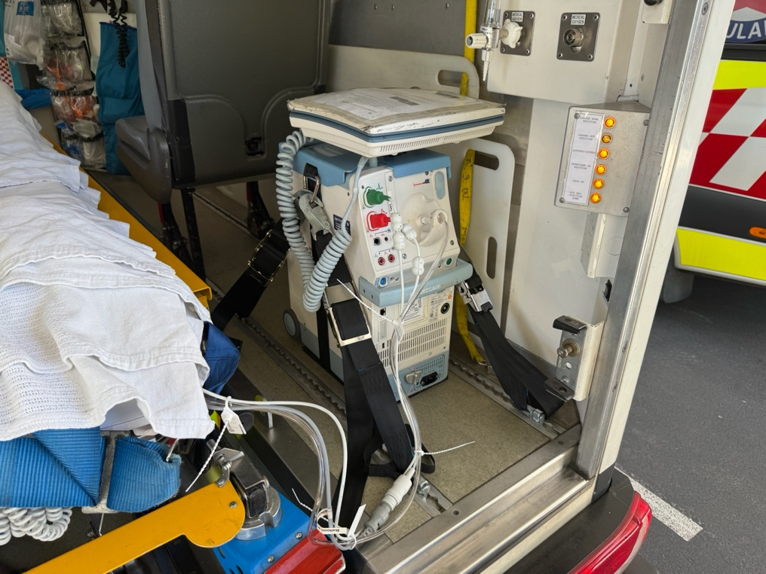

Figure 3: Pump is secured on rear right floor on MPV. The black tie-down

straps are used to attach from the D-rings to the floor tracking

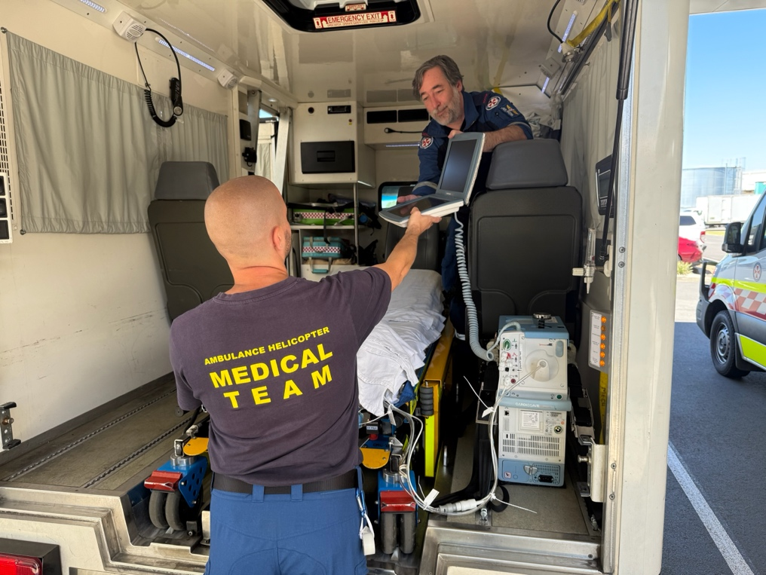

Figure 4: Hand screen to treating clinician. Ensure the device is plugged into

power

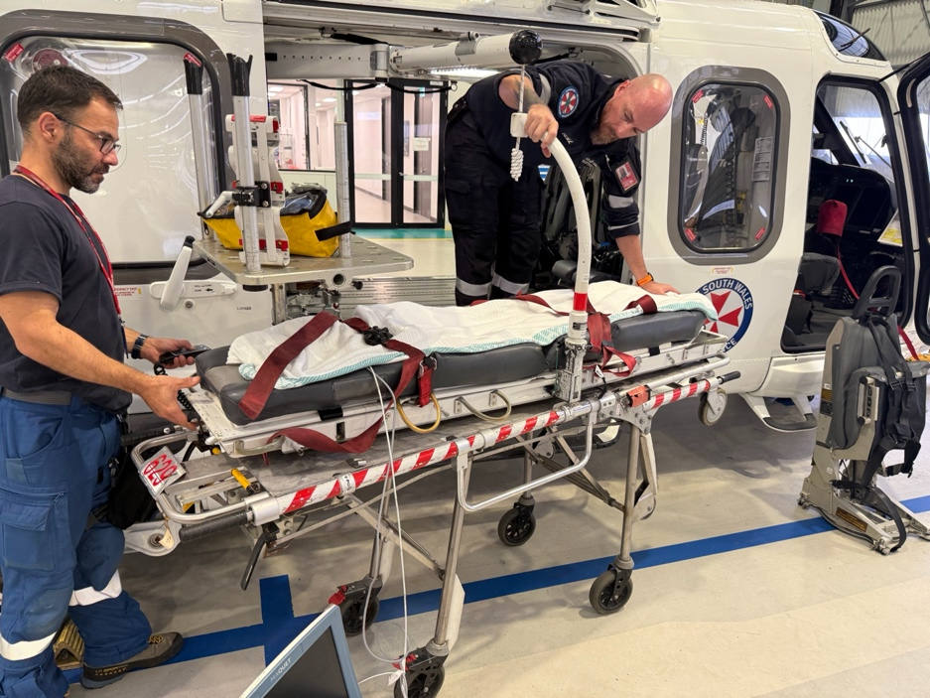
Appendix 6 – Restraint of IABP in Helicopter (AW-139)

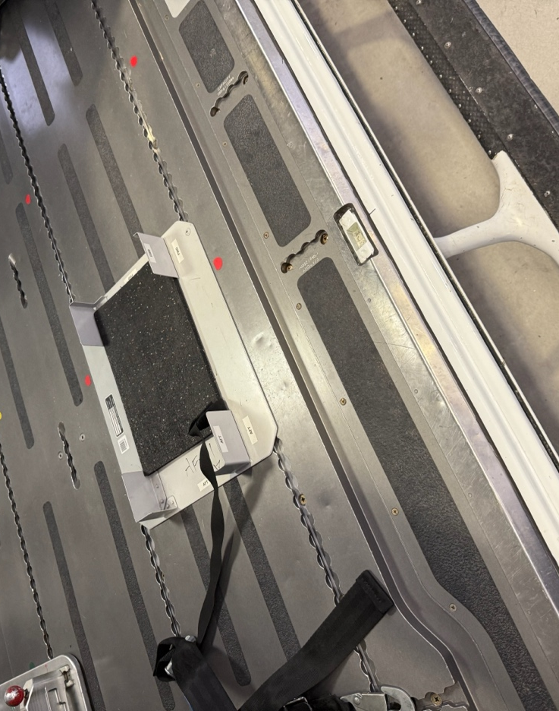
Figure 1: When packaging ensure cables and driveline are to patient’s

LEFT. Bring the pump and stretcher to aircraft and remove red tethering strap

Figure 2: Insert the floor plate and rubber mat into the aircraft floor tracking

on the right side of the cabin
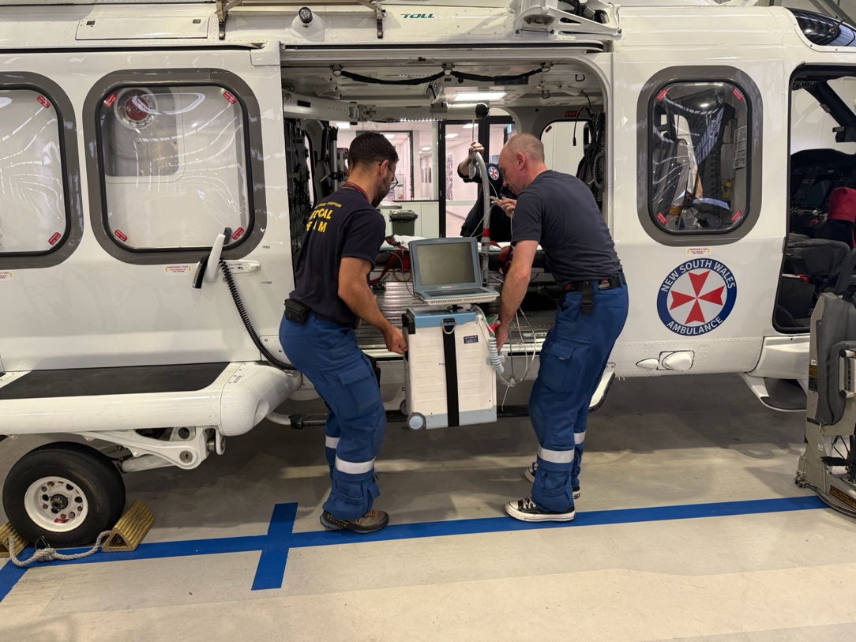

Figure 3: Load the stretcher first whilst lifting the pump on to the cabin floor

(2-person lift)

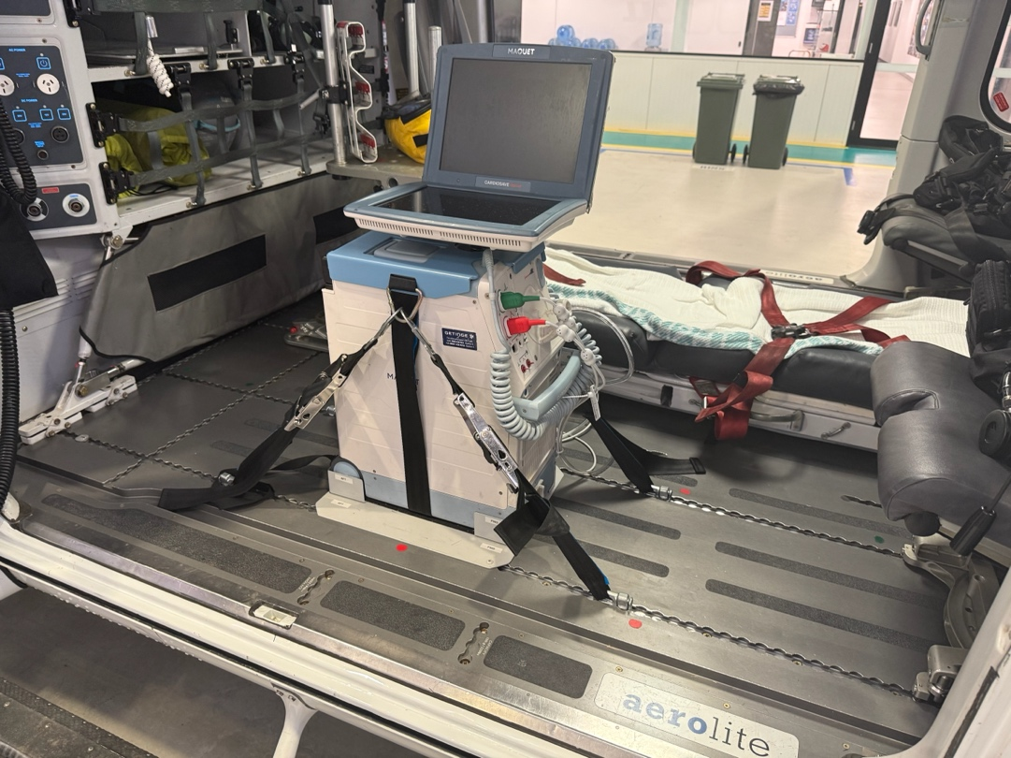

Figure 4: Insert pump into bracket. Use straps to attach the D rings to the aircraft floor

tracking. Hand screen to clinician and ensure device is plugged in to power

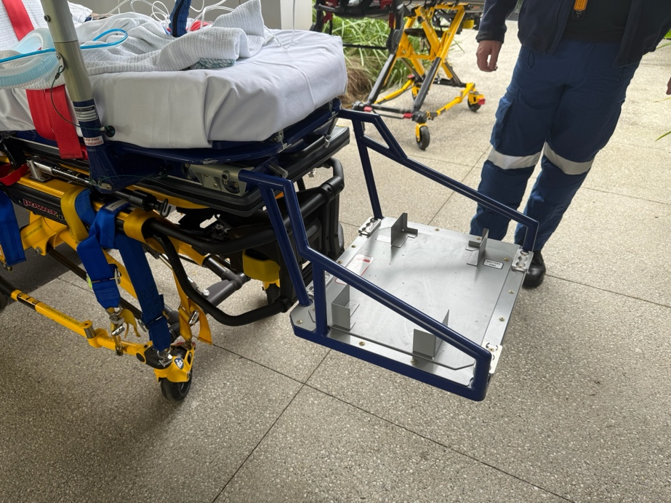
Appendix 7 – Restraint of IABP in Fixed Wing (B350 / PC-24)

\

Figure 1: : When packaging ensure cables and driveline are to patient’s LEFT.

The IAPB bracket is secured to the base of the SPS stretcher with locking pins
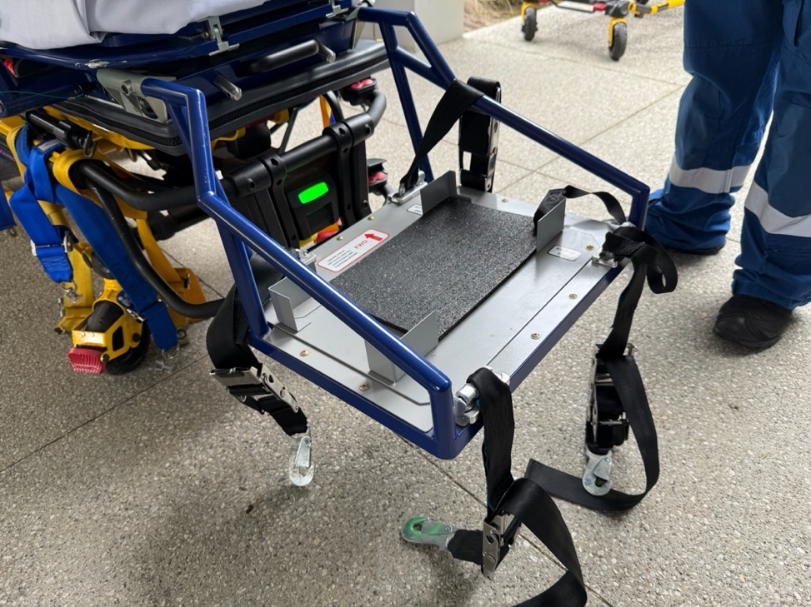

Figure 2: Attach the straps to the tracking in the four corners of the bracket and

inset the rubber mat
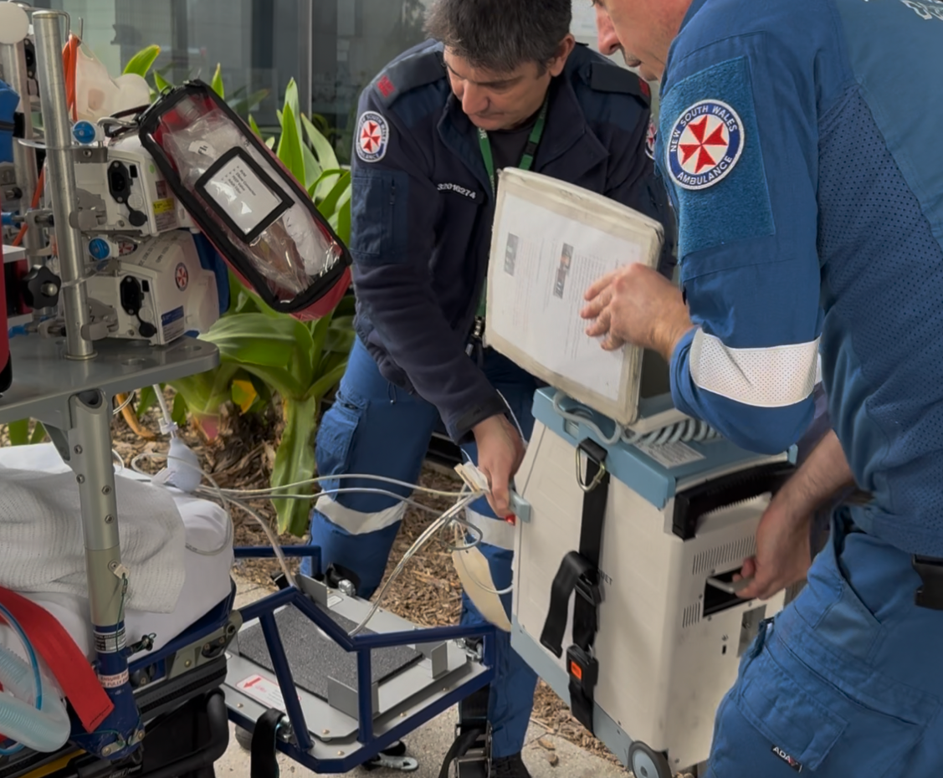

Figure 3: Lift the IABP into the backet (2-person lift)

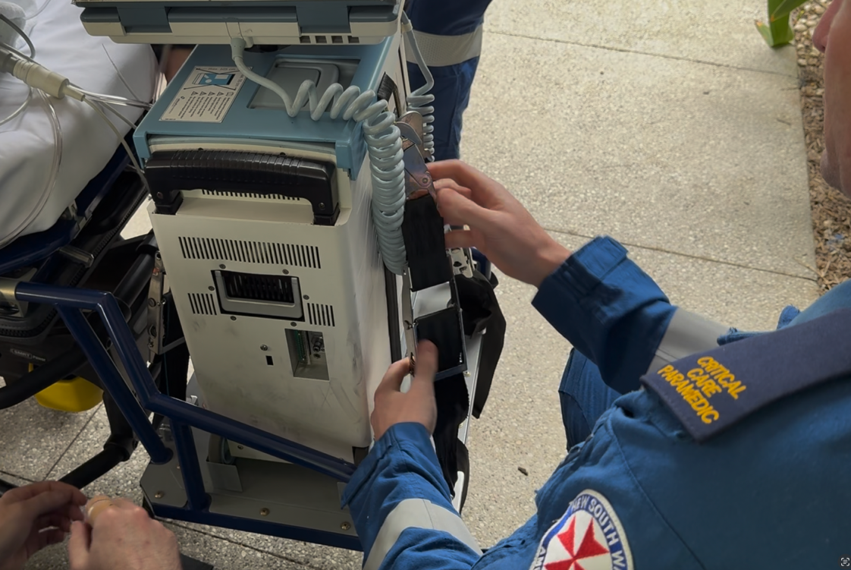

Figure 4: Attach the straps to the D rings and tighten. Hand the screen to the treating

clinician and ensure device is plugged into power
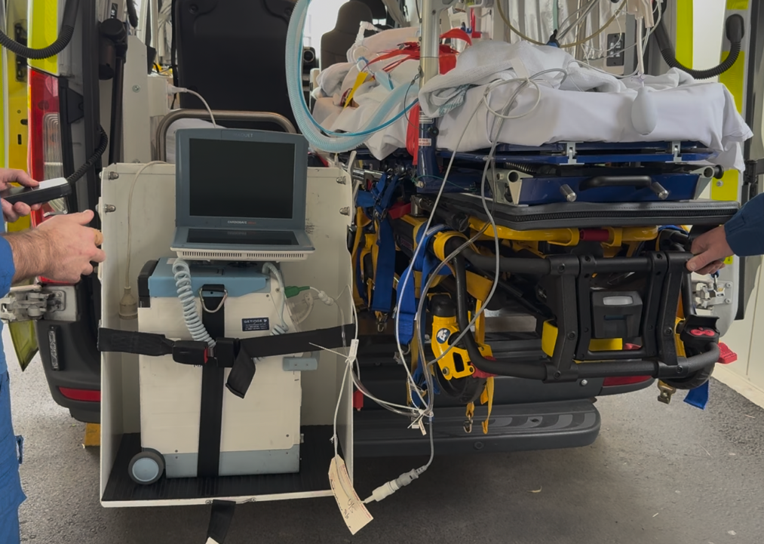

Figure 5: For road legs a vehicle with IABP lifter (or MPV) is required. Lift the device

to the floor and load pump / stretcher as per appendices 2-5

Appendix 8 – Restraint of ECMO (Cardiohelp) in Retrieval Ambulance / Cat A Vehicle
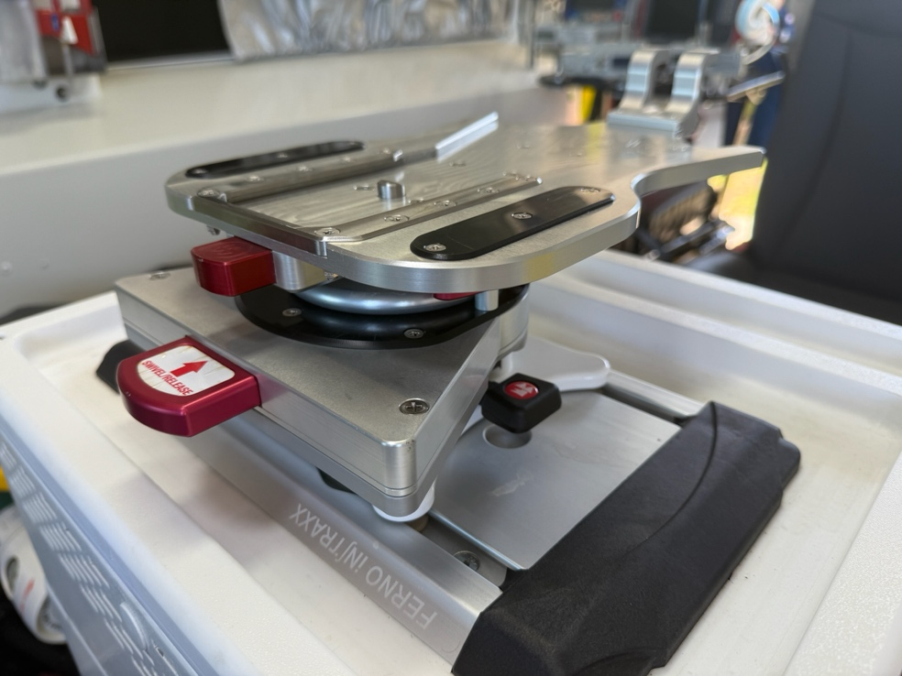

Figure 1: The Ferno Cardiohelp bracket has three red levers / buttons. Uppermost:

Disengages Cardiohelp from Bracket. Middle: Disengages centre of bracket

allowing rotation. Lowermost: Disengages bracket from iNTRAXX tracking

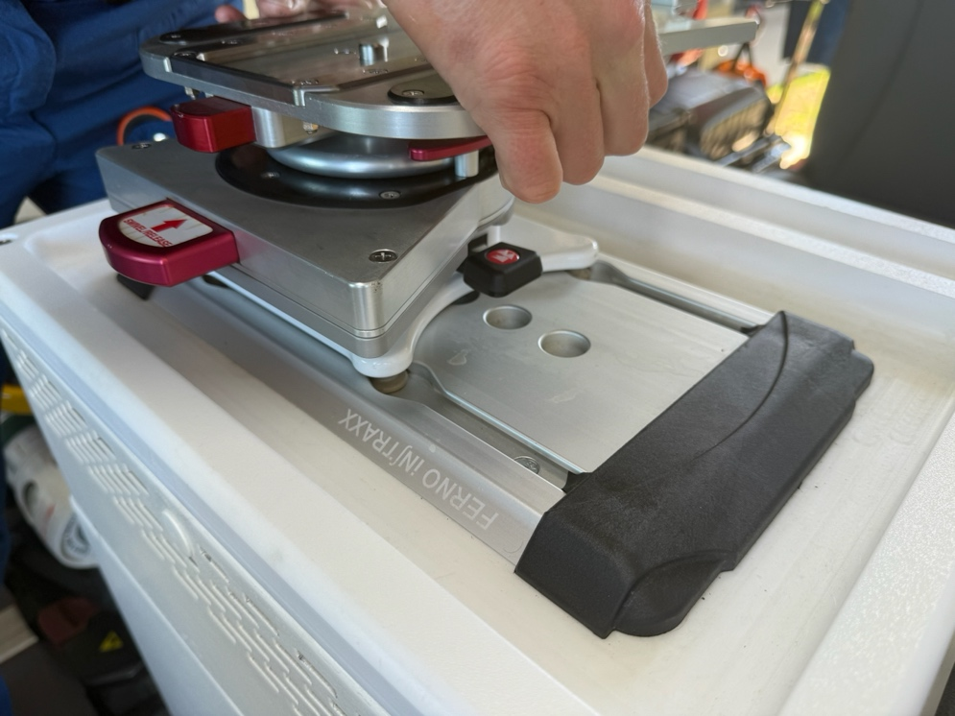

Figure 2: Insert bracket into iNTRAXX tracking and slide to lock
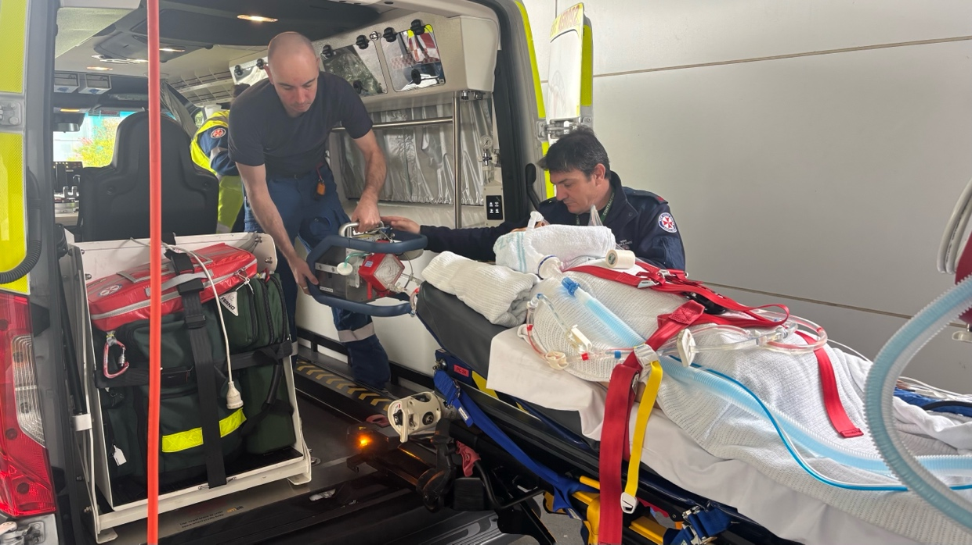

Figure 3: Pass the Cardiohelp into the vehicle ahead of or during stretcher loading maintaining

vigilance over lines and connections

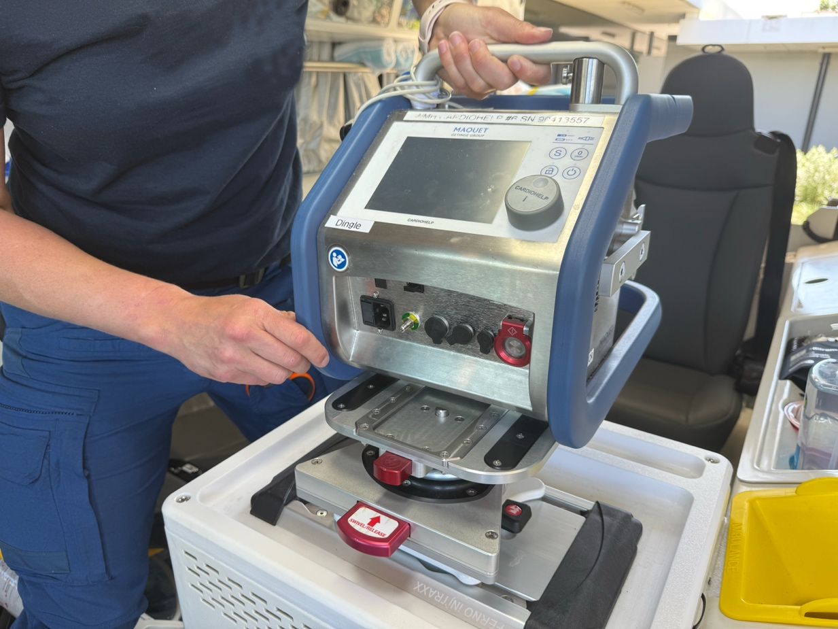

Figure 4: Slide the Cardiohelp into the bracket

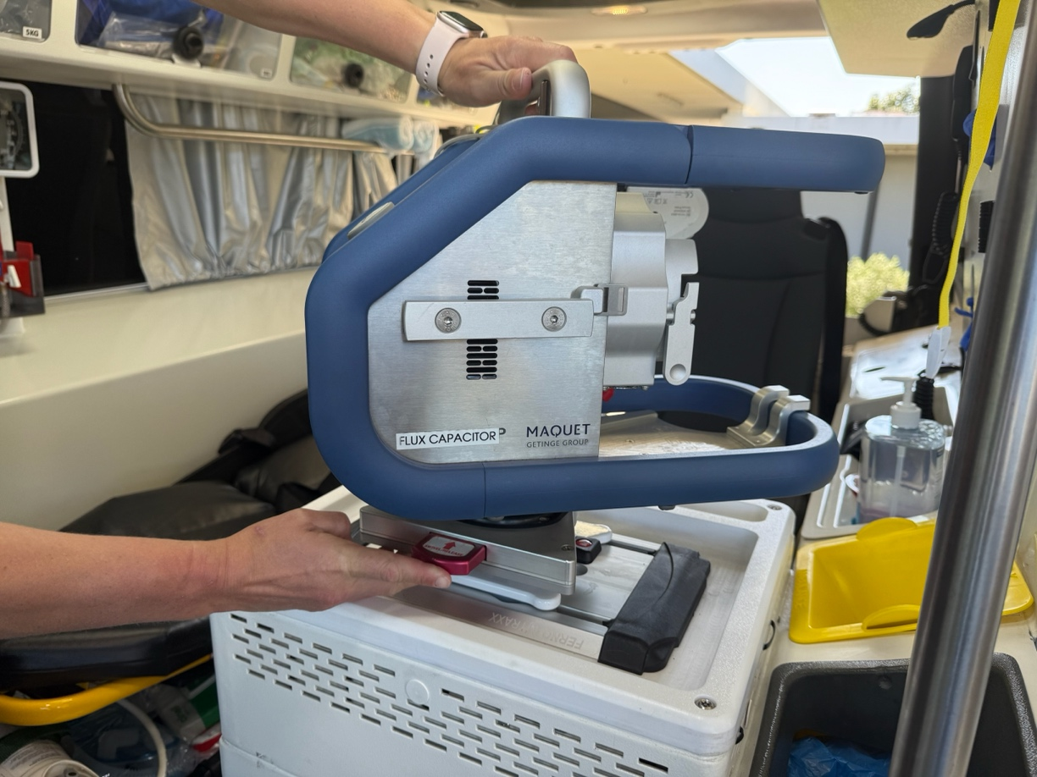

Figure 5: Press the middle button / level and rotate the device to face clinician. Ensure the device is

held firmly during rotation to prevent disengagement of the two components of the bracket. Ensure

device is plugged into power and oxygen

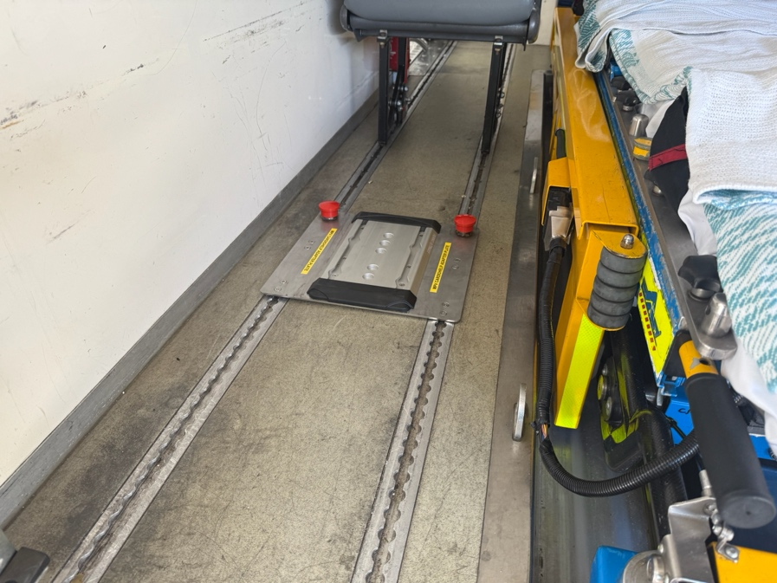
Appendix 9 – Restraint of ECMO (Cardiohelp) in MPV

Figure 1: Consider the removal or aft rotation of seats to facilitate loading.

Attach the MPV Cardiohelp Adapter Plate to the MPV floor tracking on left

hand side of vehicle. Red buttons can face forward or aft.

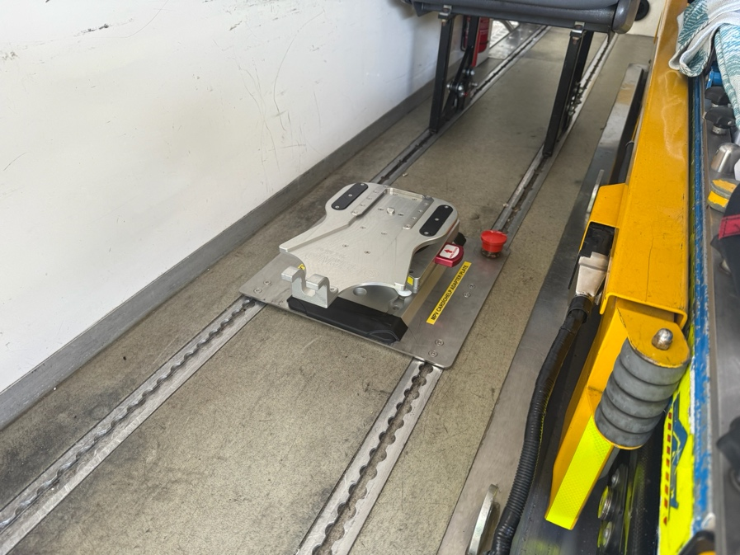

Figure 2: Attach the Ferno Cardiohelp bracket to the iNTRAXX tracking

on the adapter plate as per appendix 8

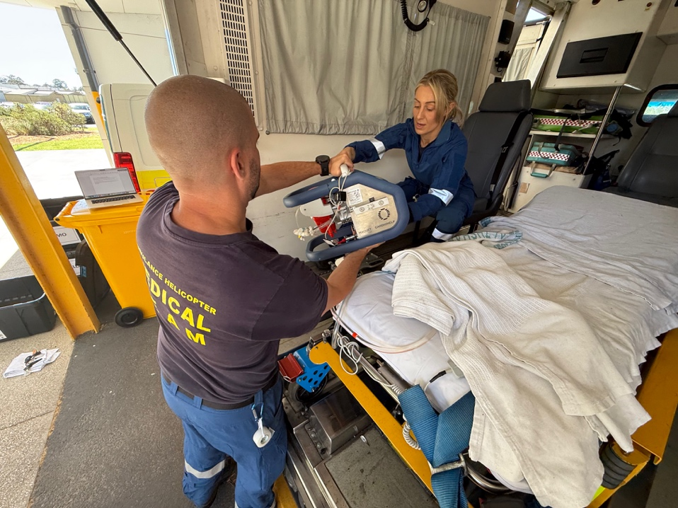

Figure 3: Lift the Cardiohelp into the vehicle simultaneous to stretcher loading

maintaining vigilance over lines and connections

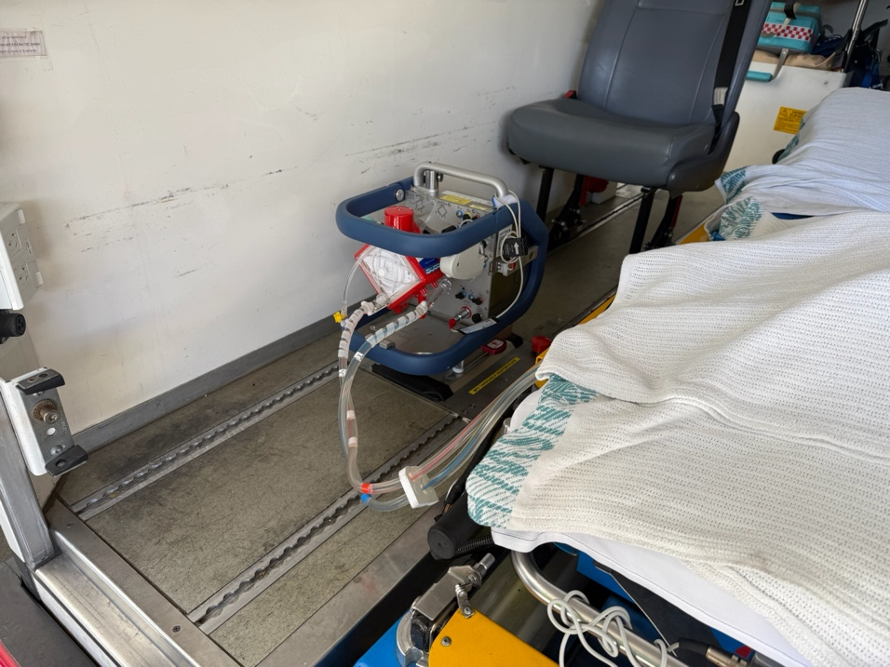

Figure 4: Slide the Cardiohelp into the bracket. Press the middle button / level

and rotate the device to face clinician. Ensure the device is held firmly during

rotation to prevent disengagement of the two components of the bracket.

Ensure device is plugged into power and oxygen

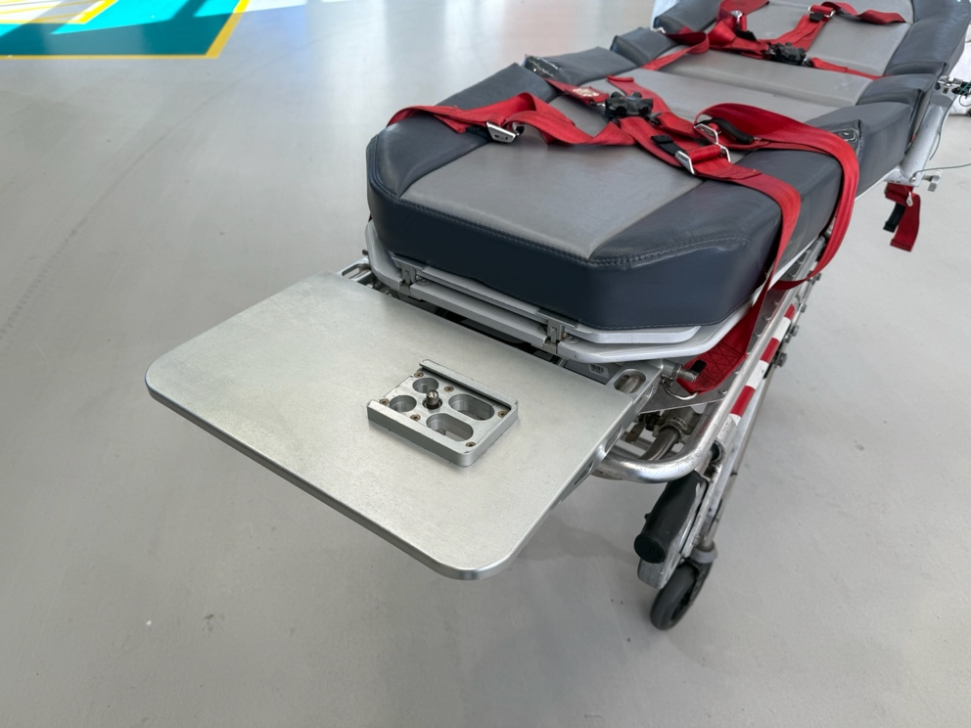
Appendix 10 – Restraint of ECMO (Cardiohelp) in Helicopter (AW-139)

Figure 1: The SPS / ECMO footplate is attached to the base of the SPS stretcher
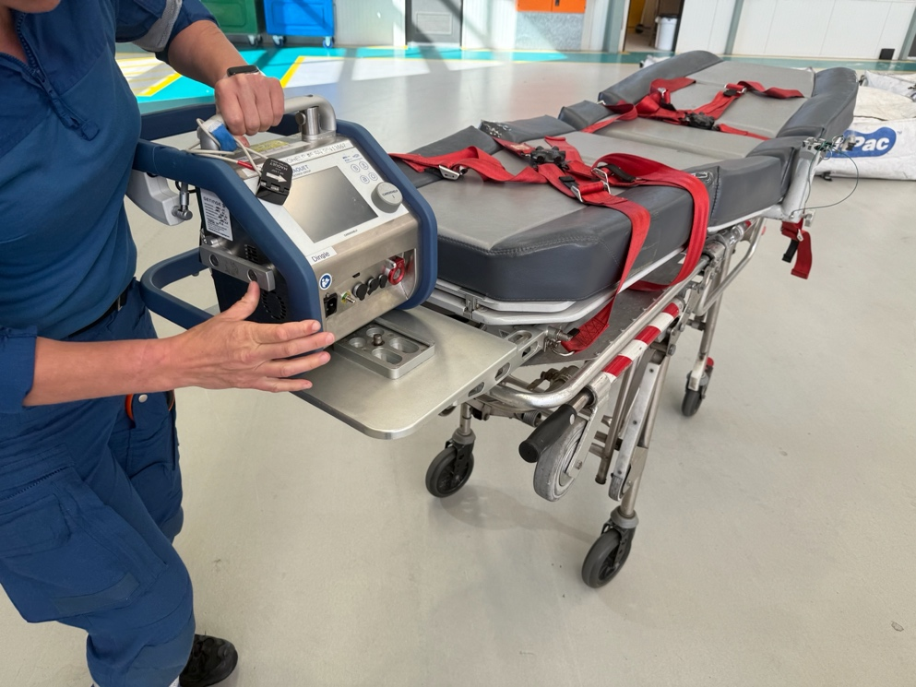

Figure 2: Slide the Cardiohelp on to the plate and secure with locking pin
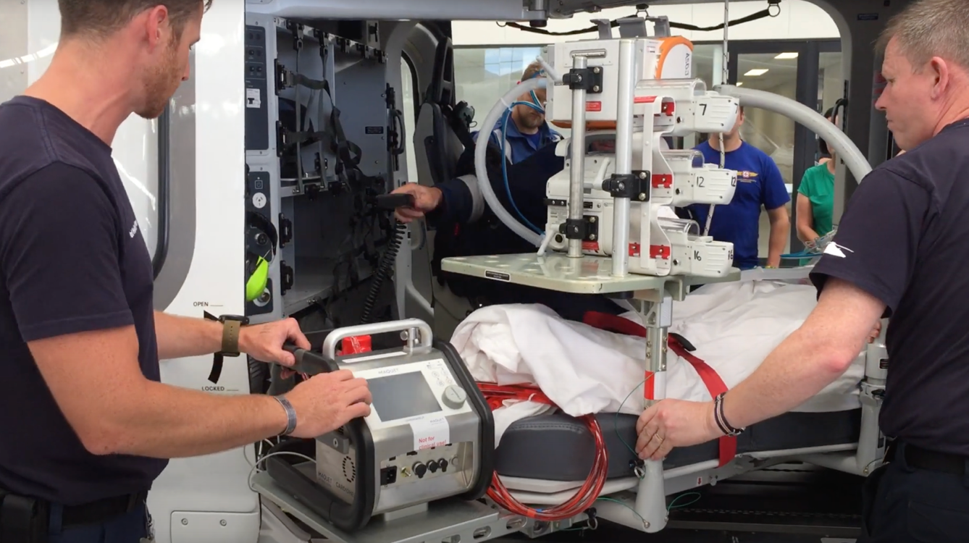

Figure 3: The rear right seat is removed for loading. Load the stretcher / footplate with Cardiohelp

maintaining vigilance over lines and connections. The ECMO console operator is seated in the rear right

seat to allow access to the device. Ensure device is plugged into power and oxygen

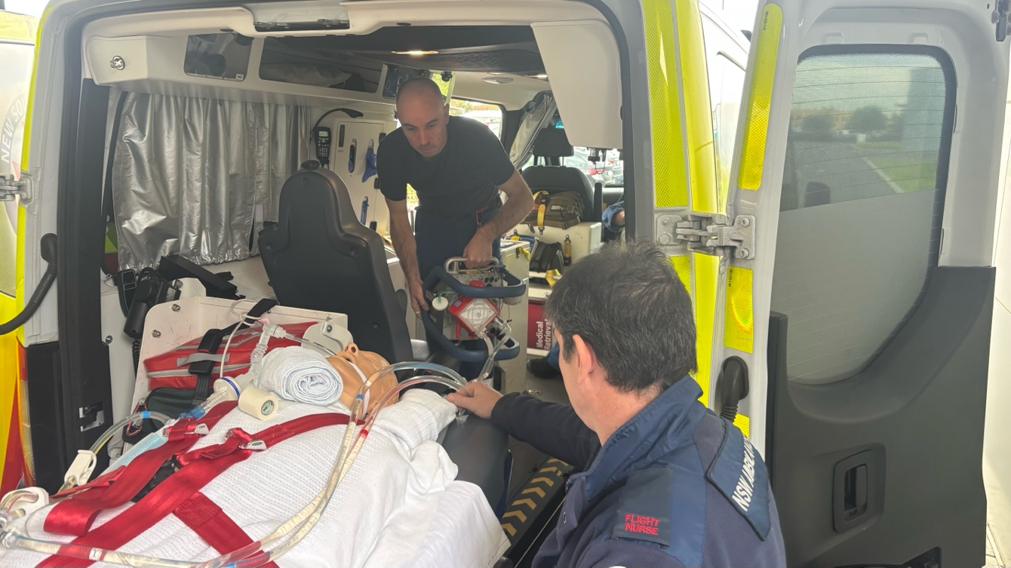

Figure 4: For road legs the Cardiohelp should be removed from the footplate and secured in the road vehicle

as per appendices 8-9

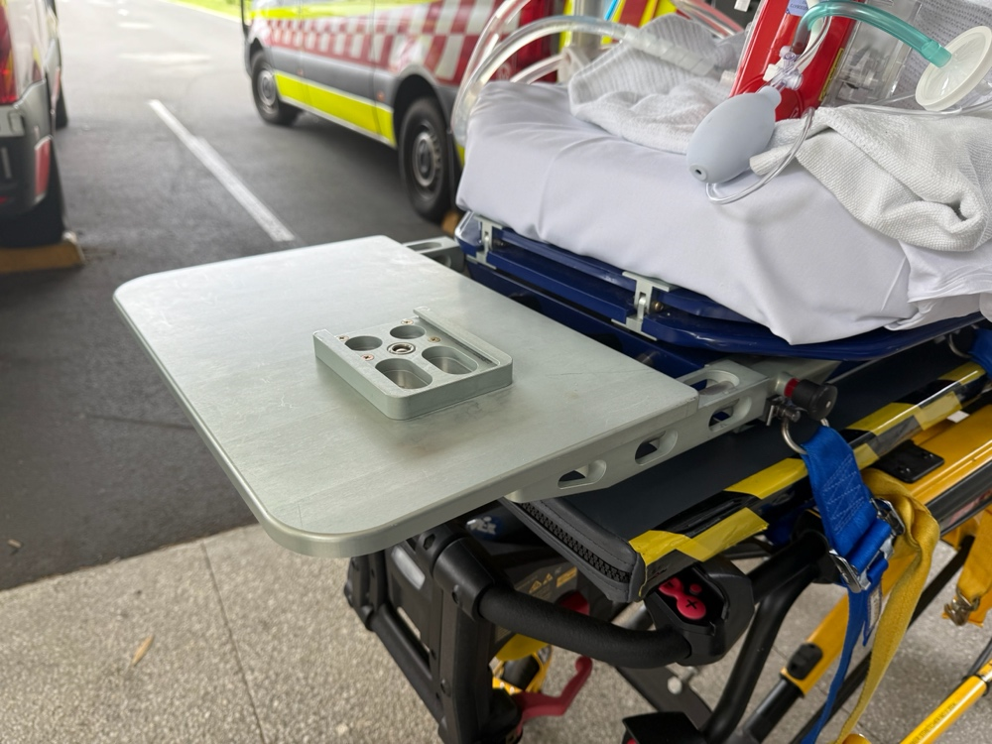
Appendix 11 – Restraint of ECMO (Cardiohelp) in Fixed Wing (B350 / PC-24)

Figure 1: The SPS / ECMO footplate is attached to the base of the SPS stretcher
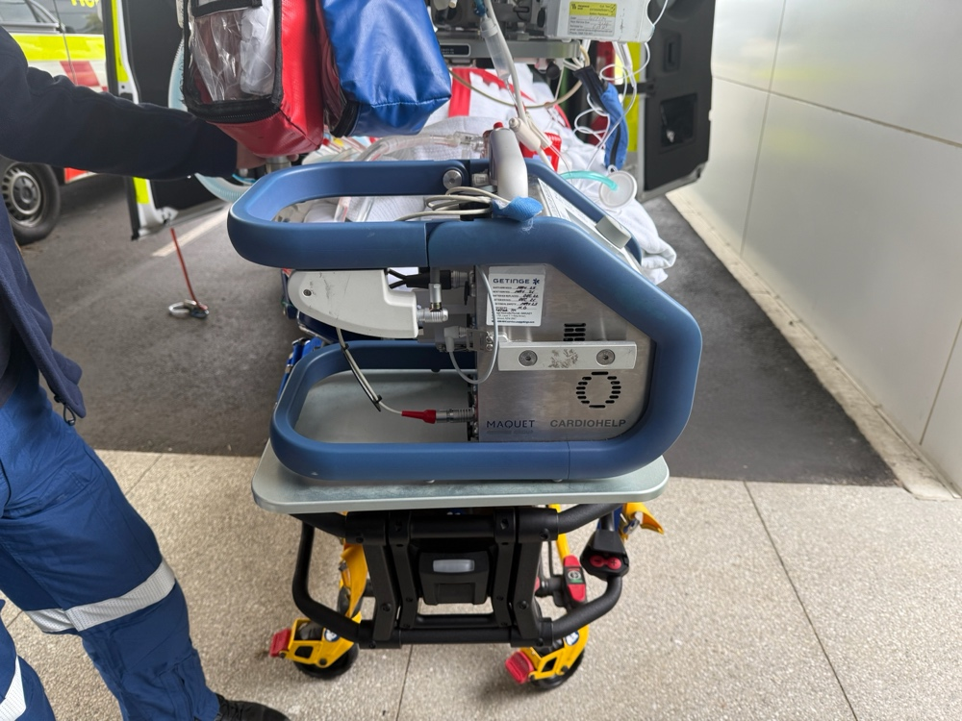

Figure 2: Slide the Cardiohelp on to the plate and secure with locking pin
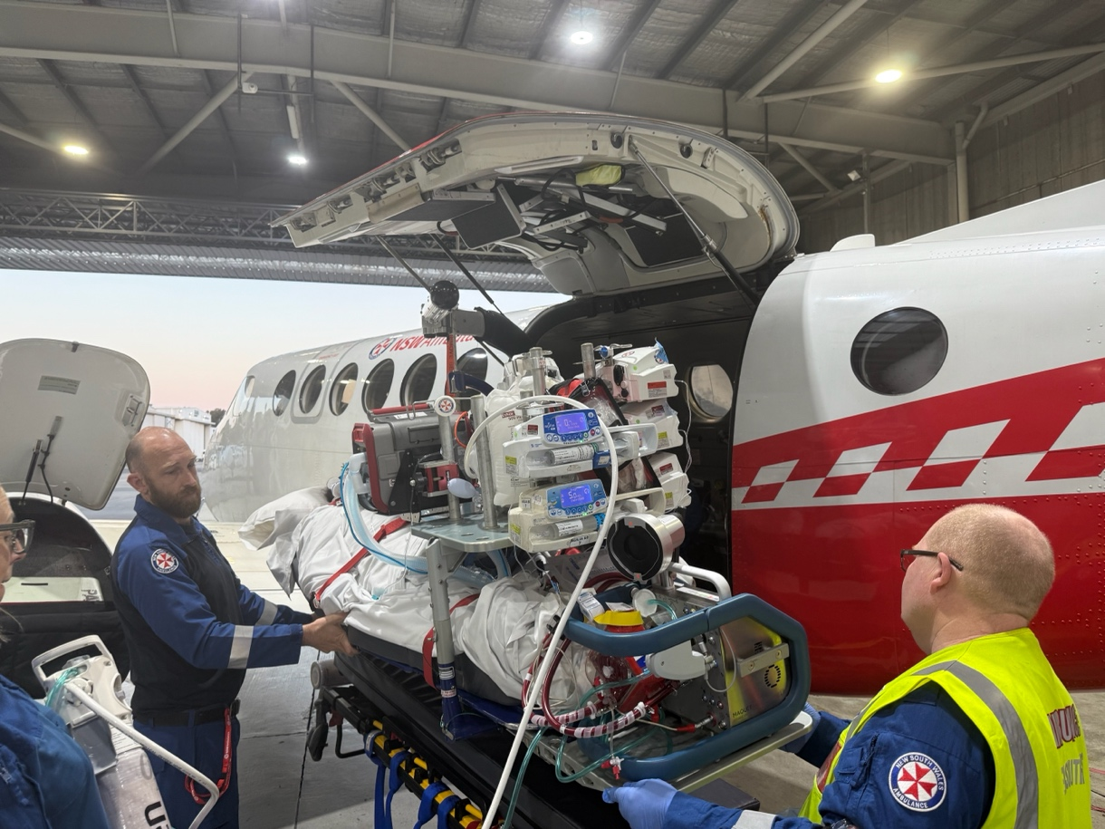

Figure 3: Load the stretcher / footplate with Cardiohelp maintaining vigilance over lines and

connections. Ensure device is plugged into power and oxygen

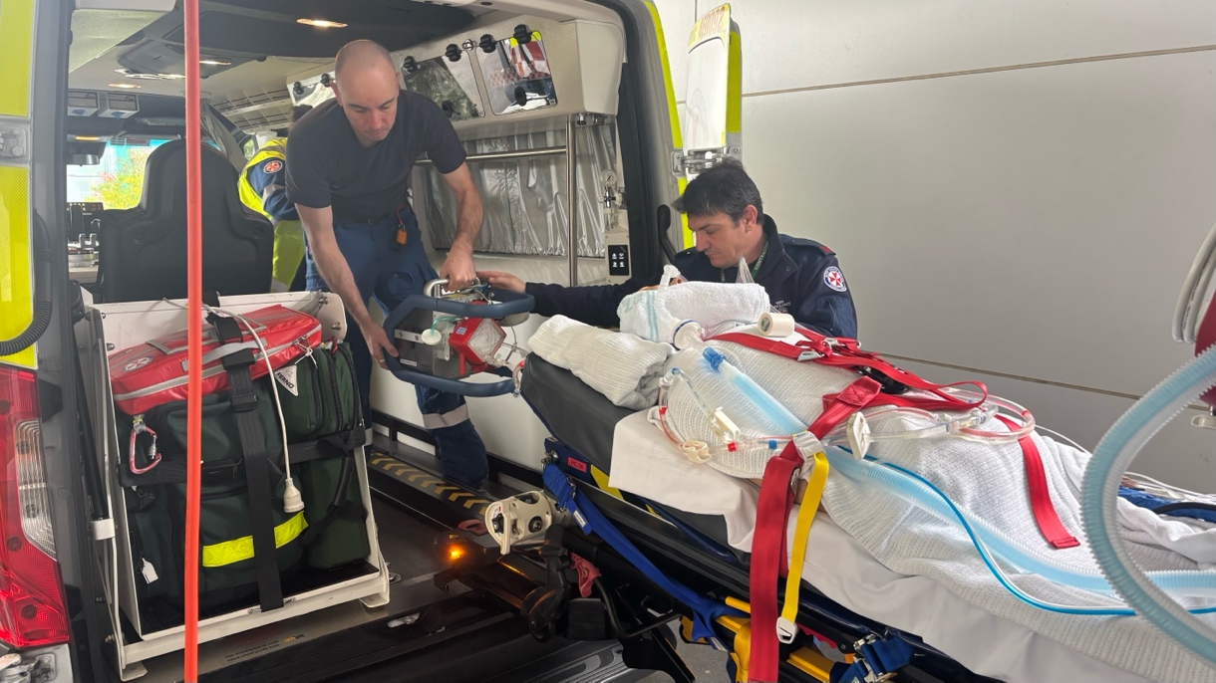

Figure 4: For road legs the Cardiohelp should be removed from the footplate and secured in the

road vehicle as per appendices 8-9

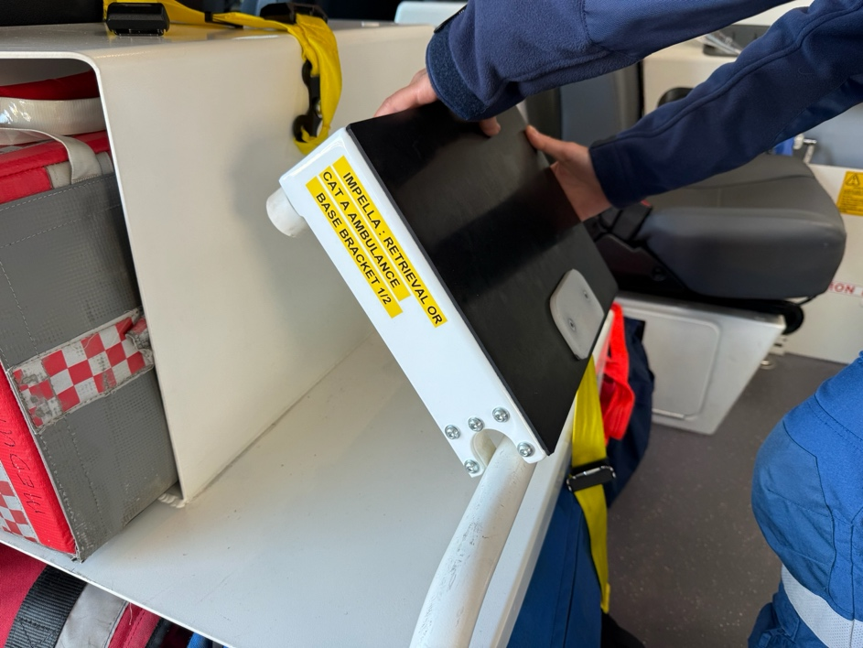
Appendix 12 – Restraint of Impella in Retrieval Ambulance / Cat A Vehicle

Figure 1: Ensure front shelving is free of equipment. Insert Impella base bracket

on to lower shelf with bar in recess
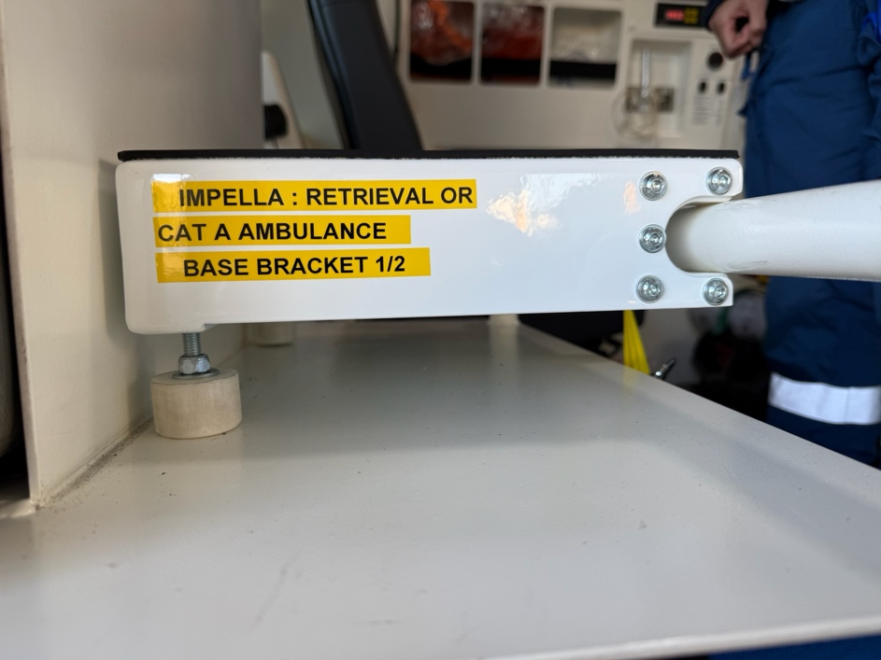

Figure 2: Adjust feet so that bracket sits parallel with shelf. Ensure airway

seat clinician is seated prior to loading the Impella due to the position of the

controller cable
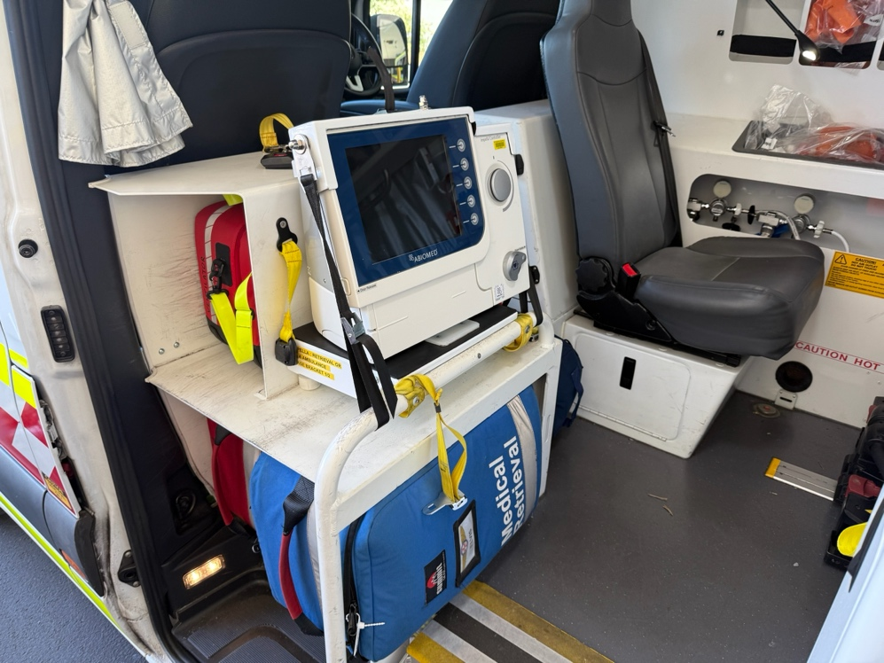

Figure 3: Pass Impella controller into the vehicle ahead of or during stretcher loading

maintaining vigilance over lines and connections. Insert Impella into base bracket, fit

top bracket and attach side tie-down straps to bar
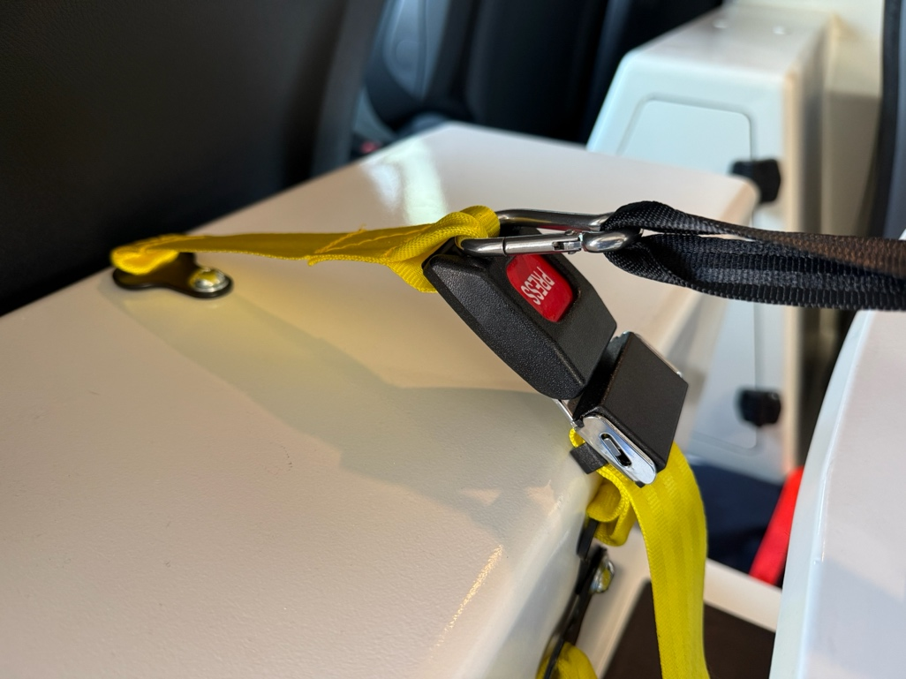

Figure 4: Attach top bracket to upper shelf seatbelts using multi-purpose carabiner.

Note the number and attachment points of top shelf seatbelts vary between vehicles.

Ensure device is plugged into power and purge bag is hung or attached to carabiner

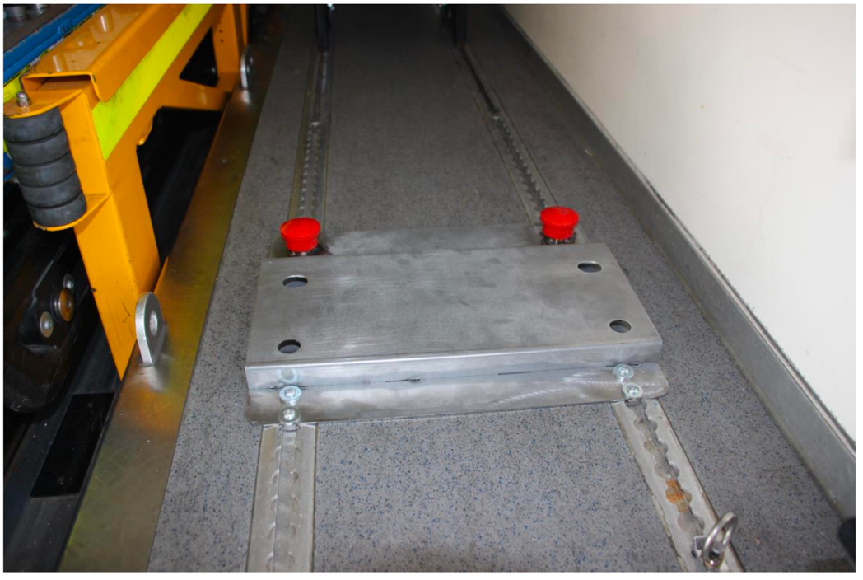
Appendix 13 – Restraint of Impella in MPV

Figure 1: When packaging ensure cables and driveline are to patient’s

LEFT. Turn rear right seat to face aft to allow monitoring of the device.

Install MPV Impella Adapter Plate to MVP floor tracking with red buttons

facing forwards
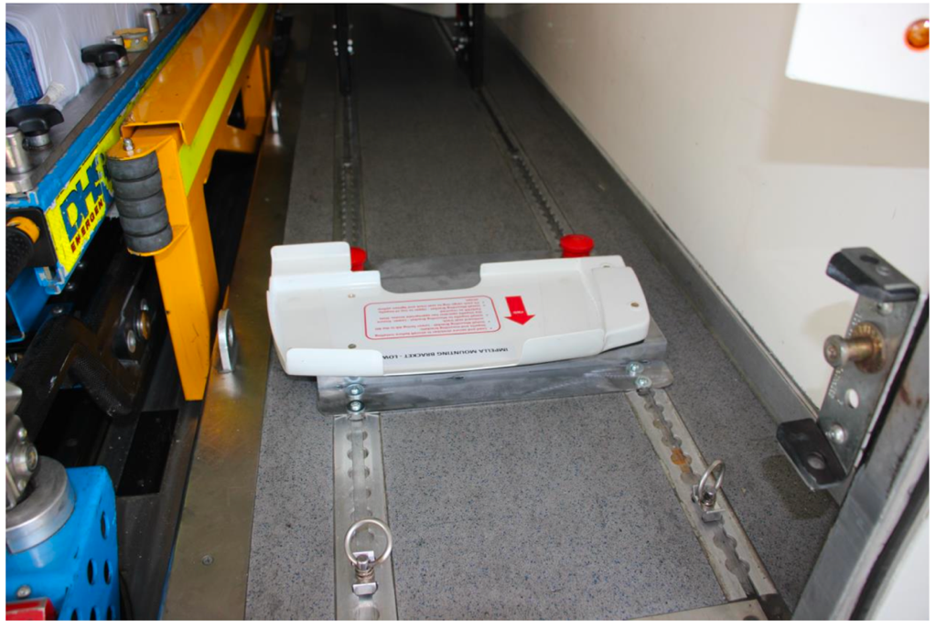

Figure 2: Attach helicopter bracket ‘Impella Mounting Bracket - Lower’ to

adapter plate with red arrow facing aft
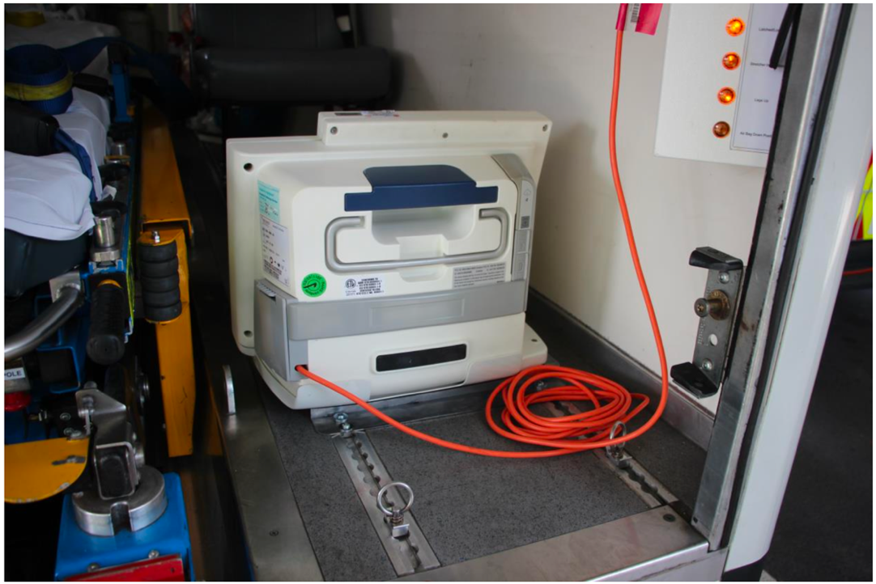

Figure 3: Lift device into vehicle simultaneously with patient loading maintaining

vigilance over lines and connections. Place into lower mounting bracket. Plug

device into power at rear right of vehicle
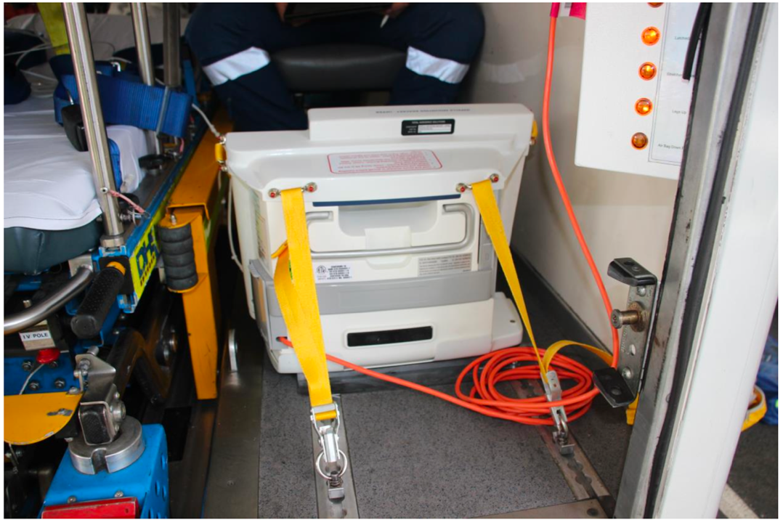

Figure 4: Attach helicopter bracket ‘Impella Mounting Bracket – Upper’ to Impella.

Fit each ring to floor tracking a minimum of 15cm from the base of the Impella

and tighten

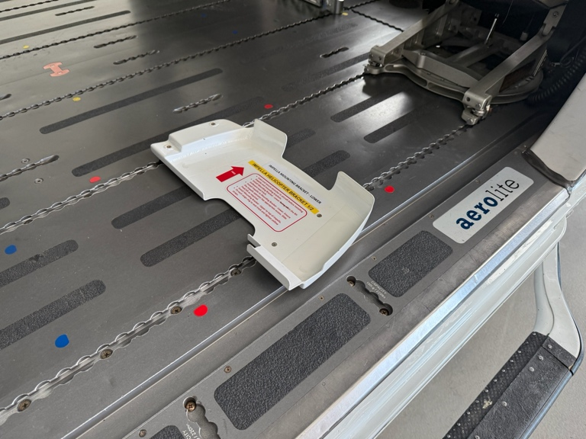
Appendix 14 – Restraint of Impella in Helicopter (AW-139)

Figure 1: When packaging ensure cables and driveline are to patient’s

LEFT. Attach helicopter bracket ‘Impella Mounting Bracket - Lower’ to

adapter plate to right hand floor of cabin with red arrow facing aft.

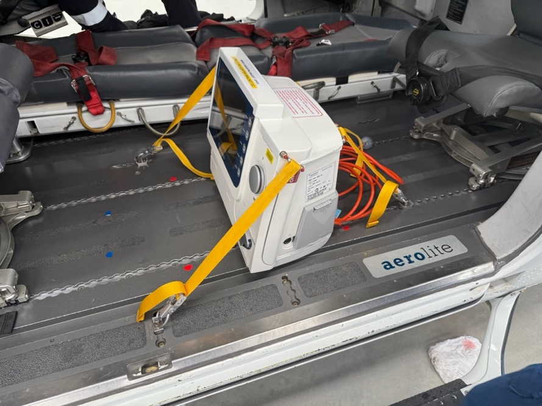

\\

Figure 2: Lift device into cabin following the stretcher maintaining vigilance

over lines and connections. Place into lower mounting bracket. Attach

helicopter bracket ‘Impella Mounting Bracket – Upper’ to Impella. Fit each

ring to floor tracking a minimum of 15cm from the base of the Impella and tighten
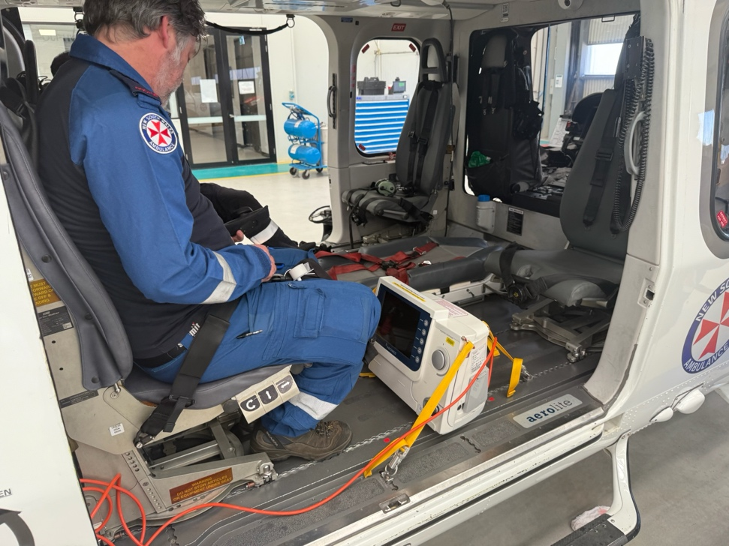

Figure 3: The clinician operating the Impella controller should be seated in the

rear left seat. Plug device into power at rear right of vehicle

