CLINICAL PRACTICE STANDARD –– Aeromedical & Special Operations
AO.CLI.14 – Neuroprotection

Document No. | D62519/26
File No. | E26/1206
Date issued | September 2026
Contents | Clinical Practice Standard | AO.CLI.14 – Neuroprotection
Contents | Appendices | Diagram detailing how the zero point should be ascertained level with the tragus and the drainage chamber secured to the bridge.
Associated Policy Directive/s and/or Operating Procedures/s
Directorate | Aeromedical & Special Operations
Author Branch | Medical Retrieval
Branch Contact | Associate Director, Medical Retrieval  Phone: 0416 371 103
Summary | The purpose of this procedure is to outline the management principles of patients being retrieved with traumatic brain injury, spontaneous intracranial haemorrhage (including subarachnoid haemorrhage) and patients undergoing management for raised intracranial pressure.
Applies to | NSW Ambulance aeromedical clinical crew.
Review Date | Sep 2027
Previous Reference | Nil
Status | Active
Approved by | A/Executive Director, Aeromedical & Special Operations, Dr Thomas Evens, 15 September 2026
Related Legislation | Nil
Related Documents | Nil
Compliance with this operating procedure is mandatory

CLINICAL PRACTICE STANDARD – Aeromedical & Special Operations
AO.CLI.14 – Neuroprotection

- Introduction
The inter-facility transfer of patients with intracranial insults, both traumatic and spontaneous, constitutes a significant component of NSW Ambulance Aeromedical Operations caseload. Prevention of secondary injury and further physiological insults are the keys to maximising the chances of a good neurologic outcome in these patients.

- Purpose
The purpose of this procedure is to outline the management principles of patients being retrieved with traumatic brain injury (TBI), spontaneous intracranial haemorrhage (including subarachnoid haemorrhage) and patients undergoing management for raised intracranial pressure.

- Procedure
Inter-hospital Retrieval of Neurocritical Care Patients
Common reasons for retrieval of patients with TBI or spontaneous intracranial events include:
  - Traumatic intracranial bleeding for ongoing critical care +/- neurosurgical intervention at a trauma centre
  - Spontaneous parenchymal intracranial haemorrhage (ICH)
  - Subarachnoid haemorrhage for surgery or endoluminal coiling of aneurysm
  - Acute hydrocephalus requiring ventricular drainage
  - Clot retrieval following large vessel ischaemic stroke.

At the time of tasking, it is essential to assess the urgency of the transfer (need for time- critical neurosurgical/radiological intervention) as well as any particular requirements of the accepting neurological or neurosurgical team.

If a patient is being transferred for aneurysmal subarachnoid haemorrhage (SAH), consider the need for future specialist interventions like interventional radiology in order to avoid a subsequent transfer.

The main aims of management of traumatic brain injury are to prevent secondary brain injury, secondary brain insults and avoid further increased intracranial pressure (ICP).¹

  - Surgical Management¹
Patients with EDH or acute SDH are likely to benefit from early neurosurgical evacuation. Patients who deteriorate (defined as a decrease of GCS by two or more points or pupillary enlargement) should be retrieved as soon as practicable to the nearest trauma centre with neurosurgical capability.

If the transfer is expected to take longer than two hours then it is recommended ² that the team discuss surgical options with the receiving neurosurgeon. Options include:
  - On-site burr-hole exploration on-site by the most competent local practitioner, general surgeon or the retrieval physician in the regional hospital.
  - Arranging a neurosurgeon (via the Aeromedical Control Centre) to travel with a retrieval team to perform the operation.

The decision made with neurosurgical consultation is based on:
  - Estimated transfer time
  - Clinical state – GCS, pupillary sizes and light reflexes
  - Rate of deterioration
  - CT scan (if available)
  - Level of surgical experience and range of neurosurgical equipment available at the regional hospital.

  - Sedation and Paralysis
In order to avoid spikes in ICP it is imperative that the patient is treated with adequate analgesia and sedation.

Movement between stretchers and changing ventilation circuitry are events that may cause patients to cough, gag or suffer arousal unless very well sedated. The ideal sedation regimen provides adequate analgesia and is easily titratable to effect with minimal haemodynamic responses.

  - Fentanyl is an effective analgesic with sedative properties and is cardiovascularly stable.
  - Midazolam has anticonvulsant properties that may be desirable.
  - Propofol is rapidly titratable, reduces cerebral metabolism and allows for neurologic assessment shortly after weaning. It may cause more cardiovascular depression.
  - Ketamine provides excellent analgesia as well as dissociative sedation. Historical concerns about its use in patients with raised ICP are unfounded, as it generally supports MAP and hence CPP.

The use of paralytic agents should be considered in all patients with raised ICP following adequate analgesia and sedation. Whilst muscle relaxants can mask clinical signs of seizure activity they are effective in preventing coughing and gagging and patient- ventilator asynchrony that can aggravate raised ICP.

3.4 Blood Pressure Management
General Recommendations:
Cerebral auto-regulation in the injured brain may be impaired and a target CPP of 60-70mmHg is recommended. However, unless an external ventricular drain (EVD) with pressure monitoring is present, it is not possible to determine CPP. Blood pressure targets must therefore be empirically chosen and should be discussed with the receiving neurosurgical team.

  - Traumatic Brain Injury (TBI)
As discussed in the pre-hospital management of TBI, it is prudent to maintain the SBP over 100mmHg.1 2

  - Subarachnoid Haemorrhage (SAH)
In the case of unclipped aneurysmal SAH, the risk of re-bleeding in the first 24 hours must be balanced against that of subsequent cerebral vasospasm and subsequent ischaemia which peak at seven to 10 days.³

Hypertension is commonly present at the time of presentation. The evidence is weak but guidelines support targeting a SBP no higher than 160mmHg, avoiding sudden profound reduction in BP and increased BP variability.³

Immediate anticoagulation reversal in patients presenting with acute SAH is strongly recommended.3

Following surgical management or endo-luminal coiling procedures, the emphasis shifts to maintaining cerebral perfusion, and a more permissive upper limit of blood pressure (BP) may be acceptable, as with other forms of stroke.

Useful strategies to control BP in this setting include:
  - Optimising analgesia and sedation
  - Labetalol or esmolol
  - Hydralazine
  - Nimodipine infusion if preferred by neurosurgical team.

  - Spontaneous Intracerebral Haemorrhage (ICH)
Evidence for both the role and subsequent targets for blood pressure control in spontaneous ICH are similarly weak, but guidelines suggest in patients with mild-moderate severity acute ICH with SBP 150-220mmHg, smooth titration of BP lowering therapy to a target range of 130-140mmHg is safe, avoiding acute lowering of SBP <130mmHg and high BP variability.
In patients with severe acute ICH requiring decompression, EVD or ICP monitoring the evidence is insufficient to suggest a specific BP target, any BP reduction should be accompanied by maintenance of CPP of 60-70mmHg.4

  - Reversal of Anticoagulation
All patients with intracranial haemorrhage should have consideration of reversal of anticoagulation therapy as soon as possible.3 4 5
For Vit K antagonists such as warfarin, 25IU/kg Prothrombin Complex Concentrate (with further doses adjusted to INR) and 5-10mg Vit K IV should be given. PCC is preferable over FFP and should be used whenever available.
For NOACs – seek haematology advice. Dabigatran – idarucizumab 2 x 2.5g. Xabans – PCC 25-50IU/kg or andexanet alfa if available.5

  - External Ventricular Drains (EVD)6
Patients are often retrieved with an EVD in-situ. Management of these drains in transit should be discussed with the neurosurgical team, in particular the need for ongoing monitoring, intermittent versus constant CSF drainage, and the preferred drainage height (pressure).

Pitfalls with EVDs include:
  - Prolonged clamping leading to unrecognized rises in ICP or drain blockage.
  - Difficulty maintaining the EVD’s reference (zero) point at the level of the tragus.
  - Over drainage associated with patient movement or vehicle G-forces. This can lead to recurrent haemorrhage.

There are two main management strategies:
  - Keep the EVD open throughout the retrieval except during the immediate patient bed/stretcher transfers.
  - Leave EVD closed and intermittently open (every three to five minutes). This might be preferred in severe turbulence or a very rough road journey.
  - The EVD must NEVER be clamped for longer than five minutes.

The zero point should be ascertained level with the tragus and the drainage chamber secured to the bridge (see Appendix 1).

It is preferable to clamp the drain when sliding or loading the patient and at take- off/landing.

The EVD should never be flushed as this can increase ICP.

If there is acute bleeding (blood in EVD drainage) the EVD should be raised until bleeding stops and discussion had with receiving neurosurgical centre.

  - Seizure Management
Prophylactic anti-epileptics reduce the chance of early (< 1 week) seizures following TBI but do not alter long-term outcome.⁸ After SAH or ICH the routine use of prophylactic anticonvulsants is also controversial. Those patients who have suffered a seizure or who are at high risk, eg. high grade SAH with focal signs, should be considered for prophylactic levetiracetam.

Active seizures (convulsive or non-convulsive) should be managed aggressively and reversible causes excluded, eg. hypoxia, hypoglycaemia, hyponatraemia.

  - Other Adjucts
  - Hypothermia - Although demonstrated to reduce cerebral metabolism, there is no good evidence supporting the use of therapeutic hypothermia following TBI in adults.⁷
  - IV Nimodpipine - There is good evidence that enteral nimodipine commenced within 48 hours of SAH reduces the chance of delayed cerebral vasospasm, which is maximal between day four and 108.
  - There is no evidence that IV nimodipine within 24 hours of SAH is helpful, particularly as cerebral vasospasm is a delayed event, although many neurosurgical centres commence it. It is reasonable to cease a nimodipine infusion for short transfers if it poses logistic difficulties.⁸
  - There is no role for the use of steroids in TBI or SAH.

- Documentation
In addition to routine observations, pupillary responses and where feasible GCS and limb motor function should be documented regularly for all patients with neurologic emergencies.

- References
1 Brain Trauma Foundation. Guidelines for the Management of Severe Traumatic Brain Injury, 4th Edition. Neurosurgery 2017; 80(1):6–15 (decompressive craniectomy recommendations updated 2020).
https://braintrauma.org/coma/guidelines/guidelines-for-the-management-of-severe-tbi-4th-ed
2 Neurosurgical Society of Australasia. The Management of Acute Neurotrauma in Rural and Remote Locations, 3rd Edition. Melbourne: NSA; 2009.
https://www.surgeons.org/-/media/Project/RACS/surgeons-org/files/position-papers/pos_2009-9-14_management_of_acute_neurotrauma_in_rural_and_remote_locations.pdf
3 Hoh BL et al. 2023 Guideline for the Management of Patients with Aneurysmal Subarachnoid Haemorrhage: A Guideline from the AHA/ASA. Stroke 2023; 54(7):e314–e370.
https://www.ahajournals.org/doi/10.1161/STR.0000000000000436
4 Greenberg SM et al. 2022 Guideline for the Management of Patients with Spontaneous Intracerebral Haemorrhage: A Guideline from the AHA/ASA. Stroke 2022; 53(7):e282–e361.
https://www.ahajournals.org/doi/full/10.1161/STR.0000000000000407
5 Wiegele M et al. Diagnostic and therapeutic approach in adult patients with traumatic brain injury receiving oral anticoagulant therapy: an Austrian interdisciplinary consensus statement. Critical Care 2019; 23:62.
https://www.ncbi.nlm.nih.gov/pmc/articles/PMC6387521/
6 Fried HI, Nathan BR, Rowe AS, et al. The Insertion and Management of External Ventricular Drains: An Evidence-Based Consensus Statement. A Statement for Healthcare Professionals from the Neurocritical Care Society. Neurocrit Care 2016; 24(1):61–81.
https://doi.org/10.1007/s12028-015-0224-8
7 Lewis SR, Evans DJW, Butler AR, Schofield-Robinson OJ, Alderson P. Hypothermia for traumatic brain injury. Cochrane Database of Systematic Reviews 2017, Issue 9. Art. No.: CD001048.
https://www.cochranelibrary.com/cdsr/doi/10.1002/14651858.CD001048.pub5/full
8 Wilson SR, Hirsch NP. Management of subarachnoid haemorrhage in a non-neurosurgical centre. Anaesthesia 2005; 60:470–485.
https://associationofanaesthetists-publications.onlinelibrary.wiley.com/doi/10.1111/j.1365-2044.2005.04152.x

APPENDICES
- Diagram detailing how the zero point should be ascertained level with the tragus and the drainage chamber secured to the bridge.

REVISION HISTORY

Version (Document #) | Amendment notes
Version 4.0 Sept 2026 | Updated references
Version 3.0  Issued 29 July 2020  WI2020-081 | Edited notes on EVD use including how to manage acute bleeding.  Transition to new format and naming convention  Approved by Executive Director, Aeromedical Operations
Version 2.0  Issued 31 March 2017 | Minor amendments and transition to new format.  Approved by Executive Director, Health Emergency & Aeromedical Services.
Version 1.0  Issued May 2013 | Approved by Executive Director, Health Emergency & Aeromedical Services.

APPENDIX 1
Diagram detailing how the zero point should be ascertained level with the tragus and the drainage chamber secured to the bridge.

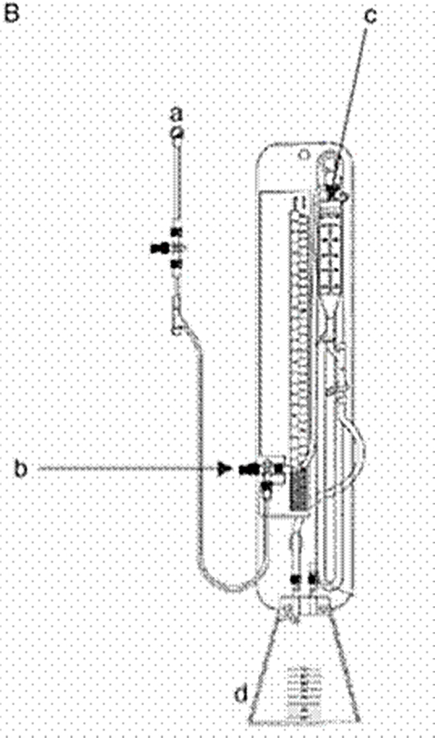

Figure 1⁶
- Patient connection.
- Three way tap for connection to drain and/or pressure transducer. “Zero point” should be set at the level of the patient’s tragus.
- Drip chamber set at prescribed distance above “zero point”.
- Drainage bag.

