Greater Sydney Area Helicopter Emergency Medical Service Research Guideline.
Version 1.2 Dated 27 Oct 2017
Background
Sydney HEMS aims to provide excellence in prehospital clinical care though the use of evidence based medicine, training, ongoing education and standardised operating procedures. Research at Sydney HEMS should be considered in the same manner. Internationally, there have been a number of developments to the conduct of research aimed at preventing poor quality studies. These include pre-registering of scientific studies to maintain methodological rigor and avoid of data-mining, ethical approval for all projects intended to be presented at forums outside of the organisation (and for publication) and making de-identified data open-access for others to use and review.
The following protocol aims to standardise how research is conducted at Sydney HEMS. In doing so, we hope to achieve three main objectives;
- Provide access to basic teaching on research methods and ethics
- Allow all projects to be compliant with local and international research standards as expected by international medical journals well before submitting for publication.
- Have an auditable process so that anyone asking for the specific methods, data analysis plan or qualifications of research personnel can easily access this information
Proposed research process (see Figure 1)

This involves several steps prior to data collection. No step is particularly difficult and all are there to ensure scientific and ethical integrity. Any problems see Brain Burns, Sandra Ware or Matt Miller.
- If you are considering a research topic, talk with Brian Burns or Matt Miller to discuss the feasibility of completing the topic and advice on which other staff members may be interested in helping. We will then discuss your project with the research committee to get any advice before you start.
- Complete the HETI online research modules. These offer a basic introduction to research methods and ethics. All three can be completed in about 45mins. Save your certificates.
- Complete the Sydney HEMS research proposal (available at the end of this document). Delete any sections that do not apply. It is available in the research folder of air maestro, along with similar previously completed proposals to help guide you. This protocol will be adapted based on feedback.
- Fill out an ethics application. Essentially all projects need ethical approval except those that are an audit intended for internal presentation only. As of Aug 31 2017 the Ethics approval forms changed but previous ethics applications are in the research folder of air maestro to help guide you.
- After ethics committee approval, complete the site-specific application (SSA). This is needed to conduct research at the specific site. A number of questions are repeated so some of it will just be a cut and paste. Occasionally the SSA is issued with the ethics approval but this may not be the case for all studies.
- Once SSA is approved, register the study with either; the Australia and New Zealand Clinical
Trials Registry for a clinical trial or on the open science form (www.osf.io) for observational studies PRIOR to data collection.
A bit of background to this process (adapted from the BMJ guidelines to authors http://authors.bmj.com/planning-your-research/)

GSA-HEMS welcomes research proposals that target original research and can improve decision making in prehospital and retrieval medical practice, policy, education, or research. There is also a move globally to involve the public more in medical research. We would welcome research proposals led or co-authored by patients and ask researchers to state in their proposal if and how patients were involved in formulating the research question, and designing and/or conducting the research so we can learn from their experience.
All research studies must be ethically acceptable, and must follow the World Medical Association's Declaration of Helsinki. Many people consider that studies referred to as audit do not need any consideration of ethics, whereas all research must be approved by a formally constituted research ethics committee. However, the distinction between audit and research is unclear, and while historically it was assumed that audit or analysing previously collected data was always ethical, this is being increasingly questioned. Therefore, we require that all studies intended for presentation outside of the organisation either obtain ethics approval, or include a statement explaining why it is not required.

There are no fixed rules about the registration of studies or about the use and provision of study protocols, other than for clinical trials. However, GSA-HEMS actively support the registration of protocols and results in publicly accessible registries for all types of study involving human participants, particularly observational studies.

If considering case series or qualitative research, please be aware that this type of research can be more difficult to get published for the reasons outlined below.
Case series lack formal hypotheses and formal study designs that pre-specify the sampling criteria and methods, data collection, and analyses. If they had all these things they would be cohort studies. Hence a case series is rarely the best design to answer a research question, particularly when describing clinical experience with an intervention. Even when that intervention is the clinical and/or practical response to an event or a disease outbreak, the case series has scientific limitations and allows few generalisable or actionable conclusions to be drawn. A series - even if compared with a control group - cannot answer questions about appropriateness, effectiveness, and adverse effects.
However, at the early stages of the response to an unusual major event or disease outbreak, case series can provide helpful and original preliminary information for clinicians and policy makers. So we will consider case series that are sufficiently informative for clinical and public health practice or policy (preferably internationally) and are compelling, well described, and topical.

Qualitative studies: Some peer review publications do not publish preliminary, exploratory studies with limited generalisability, and this often rules out much qualitative research. Whilst qualitative studies can yield very interesting insights and questions, they don't provide firm answers and hence have limited potential to improve doctors' decisions. Data from the BMJ have shown that most of the qualitative research they have published is rarely downloaded, shared, cited, or picked up in other ways by readers. A lot of qualitative work tends to be very specific to its own setting.

Observational studies, such as cohort and case-control studies, are an important form of medical research but they are vulnerable to bias and selective reporting. When an observational study is planned we will ask researchers for:
- the scientific background and rationale for the study
- the specific objectives
- the protocol
- a clear statement of the study hypothesis or an explanation of steps that will be taken to minimise bias
- the registration plan, if the study is to be registered

We appreciate that many new ideas arise from unexpected findings in observational research, and we aim to apply the above policy in a flexible manner. Hence we will not necessarily reject an observational study just because it does not have a pre-specified hypothesis, but if it does not we will want the exploratory nature of its research question, and its design, to be fully detailed in the final report. However, GSA-HEMS gives highest priority to studies that provide strong support for inferences applicable to prehospital and retrieval clinical practice, and we think the case against data driven observational studies is particularly compelling under these circumstances.

Figure 1.
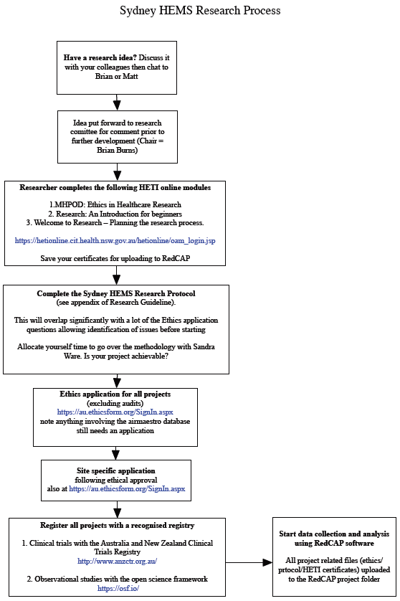
A bit more information to help;

What is classified as a clinical trial?
The World Health Organization (WHO) definition for a clinical trial is;
‘any research study that prospectively assigns human participants or groups of humans to one or more health-related interventions to evaluate the effects on health outcomes’.
This includes experimental drugs, medical devices, health service changes, preventive care strategies and educational interventions. The International Committee of Medical Journal Editors (ICMJE) recommends that all medical journal editors require registration of clinical trials in a public trials registry at or before the time of first patient enrolment as a condition of consideration for publication.
What constitutes an author on a study?
The ICMJE recommends that authorship be based on the following 4 criteria:
1. Substantial contributions to the conception or design of the work; or the acquisition, analysis, or interpretation of data for the work; AND
2. Drafting the work or revising it critically for important intellectual content; AND
3. Final approval of the version to be published; AND
4. Agreement to be accountable for all aspects of the work in ensuring that questions related to the accuracy or integrity of any part of the work are appropriately investigated and resolved.
While we dont strictly enforce the above, in general, contributors who meet fewer than all 4 of the above criteria for authorship should not be listed as authors, but they should be acknowledged.
A note about adverse events.
Just a quick reminder that any adverse event that occurs to a patient in a study needs to be notified to the ethics committee. This includes misplaced data.
How long should the literature search/background be?
Not too long. Basically, if you can’t sum up the rational for the study in 1 page it is probably too complicated however literature searches should be complete to avoid repeating previously published work. Usually the word count for a journal article is around 500 words for background, 1000 for methods, 500 for results and 1500 for discussion (4000 words would be a big article).
Expectations for data handling.

One of the biggest risks to patients, especially in studies using databases / medical records, is inadvertent unmasking and distribution of patient details. As a result we would like to adhere to the following principles;

- All patients are to be made unidentifiable by not downloading or storing names, dates of birth or addresses. The record number is to be replaced by a unique study ID at the earliest possible moment.
- Study data is to be collected using the RedCAP software. This offers a secure means to transfer and store data as well as logging all access for easy audit.
- No data is to be emailed to personal email addresses or transferred using non-secure USB drives.
- Where data analysis must occur on private laptops, hard drives are to be encrypted and files password protected (for Mac computers enable FileVault™, for Windows search Google for how to do it or just buy a Mac). On complete of the study files are to be returned to the REDCAP software for storage and deleted from personal computers.

Budgets and funding.
Currently there are no monies allocated to research and all costs of projects including time, materials and software are the responsibilities of the research team for each project. Sandra Ware and Matt Miller have access to statistical software and statistical text books.

Supporting documents.

The google drive research folder will have a selection of papers and book chapters to help you prepare your protocol and ethics application.

Appendix A:
GREATER SYDNEY AREA HELICOPTER MEDICAL SERVICE RESEARCH PROTOCOL

Full study title
Incorporating the design type (e.g. a randomized controlled study, case-control study, or retrospective cohort study)

Short title

Lay description of the project (2-3 lines only)

Study investigator(s)
name | phone | email | study role (e.g. principal investigator)

1 Background/Literature review
[max 1 page]
2 Aim(s) of study
[the aim is about what you hope to do, your overall intention in the project. an aim is generally broad. See attached documents].
Primary aim(s)
Secondary aim(s)
3 Objective(s)
[the objectives, and there are usually more than one, are the specific steps you will take to achieve your aim. they are usually more precise than the aim(s)].
Primary objective(s)
Secondary objective(s)

4 Hypothesi(e)s
Primary hypothesi(e)s
Secondary hypothesi(e)s

5 Study design
[sentence describing retrospective/prospective/randomised/clinical/crossover etc]
Study setting/location(s)
Study duration
Study population
[this is who the results are intended to be generalised to]

6 Recruitment process
Identification of participants [examples include database search, advertising at clinical governance days, and also who is going to obtain consent if consent is going to be gotten]
Inclusion criteria
Exclusion criteria

7 Study outcomes
[these need to be precise e.g ‘eto2 in %’, or ‘mortality at 30 days’]
Primary outcome
Secondary outcome(s)

8 Study procedures
[describe how the study will actually be conducted including randomisation processes etc]

9 Equipment to be used including measurement tools
[if equipment is to be used need name, manufacturer, date, and TGA approval number. If a measurement tool is to be used (this can be broad from a rating scale to an oxygen analyser), need detail on that tool including evidence of its use as a gold standard such as a reference to a paper]

10 Study involvement by participants
Recruitment and consent of participants
Withdrawal of participants from a study
Safety considerations/participant safety

11 Data analysis plan
Variables to be collected (in a table)
Statistical tests to be conducted [includes regression / descriptive statistics]
Sample size and statistical power
Missing data plan

12 Plan for dissemination of results
The results of the study will be presented at GSA-HEMs education and clinical governance days. A peer-reviewed publication is planned and if invited, a presentation or poster at local/international conferences.
13 Data security
All data will be entered and stored using REDCap software{Harris et al2009}. REDCap is a data collection and storage software hosted on the NSW Ambulance internal server and not accessable to persons outside of the organisation. REDCap meets the United States Health Insurance Portability and Accountability Act of 1996 security requirements.
REDCap also has a file repository. Any paper records generated by this study will be scanned and uploaded to the REDCap software and hardcopies will be kept in a secure filing cabinet in the Research Governance office. All electronic data and hardcopy files will be kept for a minimum of seven years and then destroyed securely. At the time of writing this protocol there is no foreseen secondary use of these data following study completion.
Harris, P. A. et al. Research Electronic Data Capture (REDCap) - A metadata-driven methodology and workflow process for providing translational research informatics support. Journal of biomedical informatics 42, 377–381 (2009).
14 Budget and resources
[include a statement about access to airmaestro if needed]
15 References

